

Internal Procedures

Section 4
Design, Project Management

VERSION
DATE
AUTHOR
REVIEWED BY
APPROVED BY
NEXT REVIEW DATE

NEXT REVIEW DATE
APPROVED BY
REVIEWED BY
AUTHOR
DATE
DOC REF

IP-01-09-01-04

This document is uncontrolled when printed. Please refer to Sharepoint for the latest version.

Contents
INTRODUCTION 1
Project Classification Definitions 2
Design Management Procedure 4
Project Management Procedure 5
Small Works Management Procedure 6
Planned Maintenance Management Procedure 6
Reactive Works Management Procedure 8
Change Management Procedure 9
Gas Safe Management Procedure 10
F-Gas Management Procedure 11
Safe Working on Low Voltage Electrical Installations 12
Electrical Inspection, Test & Commissioning Procedure 32
Electrical Visual Standards 40
Emergency Call-out Operating Rules 56

INTRODUCTION
Our procedures exist for a reason. They protect our standards, our people and our reputation. At COMPANY NAME, following procedures isn’t about bureaucracy - it’s about delivering quality work with consistency and discipline. It reflects the pride we take in doing the job properly, the responsibility we have to our customers and colleagues and our commitment to continuous improvement.
Clear processes help us manage risk early, communicate effectively and ensure that no detail is overlooked. They create fairness, accountability and a shared way of working across the Group. Most importantly, they allow us to operate safely, professionally and profitably.
Everyone at COMPANY NAME is trusted to apply judgement within the framework we provide but that trust comes with the expectation that procedures are understood, followed and upheld. Doing so protects what makes us strong today and supports our progress for the future.

Project Classification Definitions

Small Works
Small Works are projects that are generally:
- Valued at less than £30,000.
- Short duration in nature, typically completed within days or weeks rather than months
- Limited in scope and complexity
- Comprised of a single discipline or a small number of closely related work activities
- Delivered with minimal design, commercial and project management requirements
- Typically undertaken under a purchase order, quotation acceptance or simple contract arrangement
- Not subject to formal monthly applications for payment
- Not subject to retention, performance bonds, collateral warranties or other significant contractual obligations
- Low risk from a commercial, technical and programme perspective
Examples may include:
- Small electrical installations
- Minor mechanical modifications
- Equipment replacements
- Planned maintenance upgrades
- Small refurbishment works
- Reactive remedial works
- Controls modifications
- Minor HVAC alterations

Small Works Risk Assessment
The value of a project alone does not determine whether it should be managed as Small Works.
Where a project includes any of the following, it shall be reviewed by the responsible Director and may be managed under the full Project Management, Commercial and Design procedures regardless of value:
- Multiple work disciplines
- Significant design responsibility
- Complex phasing or programme constraints
- High-risk environments
- Retention provisions
- Applications for payment
- Liquidated damages
- Significant subcontract management
- Unusual contractual obligations
- Elevated health, safety or environmental risks
The responsible Director shall determine the appropriate management route where uncertainty exists.

Design Management Procedure
3. Information Control
- Request DWG/REVIT Model as line in the sand information by Design Manager.
- All the latest information to be filed in the relevant folders in the C Folder.
- Complete Design Proforma to confirm / check all design requirements and considerations. This is to then be issued to client team to comment.
- Is there a requirement for a One Drive share point to be set up? If so to be set up by Document Controller.
- Setup initial drawing register / deliverables List.
- Setup initial Technical Submission Register.
- Set up drawings received list. Project Manager/ Document Controller to be responsible for
- Design Manager/Operations/Document Control to request access to the required personnel for any external file sharing sites.
- Issue RFI’s to the client to request / confirm any information.
- Issue Technical Submissions for all pieces of plant, equipment & finishes unless otherwise agreed.
- Confirm any BIM requirements and ensure a clear BIM Execution Plan is in place and all parties understand their requirements.
4. Design
Layout Drawings & Schematics
- Allocate CAD / design resource if applicable.
- Setup drawings as per register/deliverables List.
- Develop design / working drawings in-house or use external consultants as determined in the contract handover meeting.

Des Ops
- Produce a Des Ops that details how all of the systems will operate, anyone reading should be able to understand the intended operation of all systems.

Calculations / Schedules
- Calculations are required for all systems being designed. These can be approved calculation sheets or computer modelling. Format / level to be agreed with Design Manager prior to commencing.
- Set up a deliverables schedule for all anticipated schedules / calculations.
- All schedules to be backed up with calculations.
- Calculations / schedules to be carried out on standard templates.

Early Items
- Issue Fire Damper Schedule to architectural / construction team.
- Issue initial weights for structural review.
- Issue initial E for M schedule.
- Issue initial loadings for any incoming supplies.
- Check BRUKL is a pass, identify any issues and action accordingly.

Value Engineering
- Include any previously discussed value engineering options in the design.
- Identify any possible value engineering opportunities during the design and liaise with estimating / Director responsible to see if there are any beneficial gains for the client / COMPANY NAME.

6. Quality Control
Drawings
- All drawings shall have a drawing number that is unique and in line with the Key IS Naming Convention.
- All drawings shall be on a KEY IS title block.
- The correct scale and revision should be in the title block.
- All drawings should be spell checked (set to English, not American).
- All drawings should have a legend and standard symbols used.
- All drawings should have standard notes.
- The text size/symbols should be correct for the scale of the drawing.
- The items above are the responsibility of the engineer / technician and should be checked before being offered up for final review.

Schedules
- All drawings / schedules to be checked by Design Manager &/or Project Manager prior to issue.
- All schedules shall have a number that is unique and in line with the Key IS Naming convention with revision and date.
- All schedules shall be on a KEY IS template.
- All schedules should be spell checked (set to English, not American).
- The items above are the responsibility of the engineer / technician and should be checked before being offered up for final review.
- All schedules to be checked by Design Manager &/or Project Manager prior to issue.

Document Issue
- All documents that are formally issued shall be complete with a drawing issue sheet.
- The distribution list will be advised by the Project Manager and incorporated into the issue sheet.
- The document issue shall be the responsibility of the Project Manager / Document Controller.

5. Health, Safety & Environmental
- Designers Risk Assessment (DRA) to be produced for all projects.
- All risks designed out of the project to be noted in DRA.
- All residual risks to be highlighted to make the construction team aware of any risks to take forward. These will be non-standard risks (i.e., don't include information that a competent contractor shall already do like working at height).
- Any additional maintenance access requirements should be highlighted.
- All items of plant should be maintainable and accessible. A review of this should be carried out and any additional requirements added to the design or advised to construction team (I.e., walkways, hatches).
- Is there a risk register from the client team? If so, this needs to be incorporated/reviewed.
- COMPANY NAME WILL NOT BE RESPONSIBLE FOR ANY DSEAR ASSESSMENTS. THIS SHOULD BE A CLIENT RESPONSIBILITY.
- Pre-Contract Handover Meeting
- Appoint Design Manager, Pre-construction Manager & Project Manager.
- Complete Job Opening Sheet.
- Open project on accounts software & set-up contract file on Sharepoint & create hard copy. To be laid out as per document 02-01-06.
- Review client’s requirements.
- Review latest tender proposal.
- Review latest drawings.
- Review latest specifications.
- Review latest quotations.
- Review latest calculations.
- Review the contract & related documents & that the tender is a true reflection of what is required – highlight any pitfalls & agree how to mitigate.
- Confirm costs for adequacy.
- Go through the project in its entirety so that the Design & Pre-Construction Manager understand the scheme in full.
- Prepare Design Programme
- Agree design period with client / main contractor.
- Agree and prepare a Design Programme listing out the deliverables.
- Highlight from programme long lead items & prioritize during design & procurement.
- Design Manager to notify client immediately with any issues with delivery dates / programme & plan accordingly.
- Design Manager to notify Project Manager immediately with any issues with delivery dates / programme & plan accordingly.
- Access impact (and cost) of 3rd party interfaces i.e:
- External Revit / CAD resources.
- External design Resources (if required).
- Any Thermal modelling (if required).
- Any BREEAM/BRUKL requirements.

Microsoft Projects
02-04-01 – Job Opening Sheet

02-05-01-13 – Designers Risk Assessment
02-03-57 – Design Survey MS

02-05-01-05 - Drawing Register
02-01-06 – Contract Index Sheet 1-20
02-01-07 – RFI Template
02-01-08 RFI – TQ Register
02-05-01-11 – Technical Submission Register
02-05-01-12 – Technical Submission
02-05-01-26 – Design Pro-Forma
02-05-01-28 – Deliverables Template
02-01-26 – Design Folder Index

ROLES AND RESPONSIBILITIES
Tender Information Estimator
Transfer Design Info to C Folder Design Manager
Job Opening Director / PM
Tech Subs – Prepare Project Manager
Tech Sub – Checking Design Manager
Tech Subs – Issue Project Manager
Drawing – Prepare Design Team
Drawings – Checking Design Manager
Drawings – Issue Design Team
RFI/TQ – Populate Design Team
RFI/TQ – Issue Design Team
Calculations – Prepare Design Team
Calculations – Checking Design Manager
Calculations – Issuing Design Team
Schedules – Preparing Design Team
Schedules – Checking Design Manager
Schedules – Issuing for pricing Project Manager
O&M Information Project Manager
02-05-01-05 - Drawing Register
02-05-13-## - Calculation Templates
02-05-14-## - Equipment Schedules
02-05-15-## - Drawing & Installation Standards Drawings
02-05-17-## - Fire Damper Typical Detail

02-05-11-12 - Design Checklist
02-05-01-26 – Drawing & Schedules Quality Checklist
02-05-11-13 – Drawing Numbering Convention
02-05-15-## - Drawing & Installation Standards Drawings

- Design Changes
- All design changes that are not design development should be agreed with the Project Manager prior to be being undertaken/incorporated.
- The extent of the changes shall be highlighted to the Project Manager so additional design costs can be assessed, along with the physical installation costs.
- Design manager to confirm lead time for design changes to be incorporated.
- Any changes in procurement shall be captured by the Project Manager to ensure that the latest information is correct i.e. reissue tech subs, update procurement quotes with relevant technical data/information.

- Design Handover
- Attend Contract Handover Meeting, ensure that the project management team understand all aspects of the project, include the following:
- Drawings - Layouts
- Drawings - Schematics
- Schedules
- Calculations
- E for M schedule
- Des Ops
- Designers Risk Assessment
- Design Manager to propose meeting date for handover to construction team

Project Management Procedure
- Health, Safety & Environmental Planning
- Prepare Health, Safety, Environmental & Quality Site File.
- Complete method statement & risk assessments that are relevant to the works being completed. If using generic RAMS from folders 05-07 & 05-08 from Sharepoint read through them & adapt to site conditions.
- Ensure material safety data sheets are available & COSHH assessments are completed for all substances to be used & stored in the H&S file.
- Determine first aid resources are adequate.
- Determine and ensure availability of welfare facilities.
- Ensure suitable permits to work / hot works & confined space procedures are adequate.
- Identify site rules & incorporate into HS&E manual, distribute to supply chain.
- Request copy of Asbestos register & incorporate into HS&E manual, distribute to supply chain.
- Produce Site Waste Management Plan as per Environmental Procedure.
5. Site Familiarization / Set Up
- Investigate, carry out site briefing on site with delivery team.
- Establish site office area in which to display relevant notices, H&S Law Poster, H&S Policy Statement, site rules & store H&S site files, paperwork & data. Setup at per COMPANY NAME Standard Site Establishment standards document.
- Issue / set up site diary & site entry log system
- Ensure site welfare / first aid are set up & available for use.
- Ensure site setup is tidy & professional, there should be ‘Key’ signage identifying the cabin / office location. All cabins should have printing facilities & internet access.
- Complete relevant checklist / monitoring forms & that site setup is compliant & up-to standard.
- Contract Handover Meeting
- Appoint Project Manager & Site Foreman.
- Complete Contract Handover Meeting Minutes.
- Complete Job Opening Sheet.
- Open project on accounts software & set-up contract file on Sharepoint & create hard copy. Both to be laid out as per document 02-01-06
- Review client’s requirements.
- Review the contract & related documents & that the tender is a true reflection of what is required – highlight any pitfalls & include in costs.
- Confirm costs for adequacy.
- Complete Project Analysis Sheet.
- Go through the project in its entirety so that the Project Manager understands the scheme in full.
- Prepare Work Programme
- Agree installation period with client / main contractor.
- Communicate agreed programme with supply chain and finalise project specifics.
- Finalise delivery team including all labour & sub-contractors if applicable.
- Highlight from programme long lead items & prioritise during procurement.
- Notify client immediately with any issues with delivery dates / programme & plan accordingly.
Microsoft Projects
4. Design / Drawings
- Allocate CAD / design resource if applicable.
- Develop design / working drawings in-house or use external consultants as determined in the contract handover meeting.
- Setup drawing register.
- Establish responsibilities for as-fitted drawings & O&M compilation.
- Agree O&M format with client.
- Issue RFI’s to the client to request / confirm any information.
- Issue Technical Submissions for all pieces of plant, equipment & finishes unless otherwise agreed.
02-05-01-05 - Drawing register
02-01-07 – RFI Template
02-01-08 RFI – TQ Register
02-05-01-11 – Technical Submission Register
02-05-01-12 – Technical Submission

6. Procurement
- Establish delivery procedure to site & communicate to supply chain.
- Issue sub-contract orders to approved sub-contractors as per purchasing procedures & update on Project Analysis sheet.
- Issue supplier purchase orders & update on Project Analysis sheet.
- Complete procurement tracker, check against programme & highlight any issues – report upstream & to client immediately.
- Check deliveries against orders & file delivery notes in site file.
7. Installation
- Induct all personnel attending site & ensure all have CSCS / Skillcards (exemption only to accompanied visitors)
- Supply, install, test & commission services in compliance with the client’s specification & drawings, and or design brief / employer’s instructions.
- If the Project Manager is not site based ensure regular contact with relevant Project Manager.
- Ensure information flow is effective & where applicable record / minute / distribute in writing.
- Receive instructions & act accordingly, document verbal instructions as applicable.
- Attend site meetings & respond to actions as required.
- Monitor & cost variations to requirements of contract & review on a regular basis.
- Review programme / strategy at regular intervals paying special notice to critical deadlines & milestones.
- Apply for monies on a regular basis as per contract agreement.
- Review financial situation monthly & include in Project Commercial Report.
- Request / obtain supplier information for O&M manuals.
- Mark up drawings to accurately document ‘as-fitted’ plant and / or services at regular intervals throughout the contract.
- Ensure complaints are dealt with as per complaints procedure & escalated to Director level.
- Towards the end of the project complete the Outstanding Works & Defects List & distribute to supply chain as necessary to highlight remaining works – monitor closely.
- Ensure ‘Inspection & Testing Procedures’ are followed.
- Ensure ‘Gas Safe Management Procedures’ are followed.
- Ensure ‘F-Gas Management Procedures’ are followed.

Daily Tasks
- Maintain site diary to accurately reflect day to day activities / attendance / training.

Weekly Tasks
- Complete progress report weekly & issue as agreed.
- Check hire report weekly & off hire all plant at earliest opportunity.
- Complete inspection & audit sheets weekly & snag installation as the project progresses.

- Commissioning
- Produce Project Commissioning Tracker for all items proposed to be commissioned, issue to client for comment / approval.
- Carried out by competent personnel prior to offering to the client for witnessing.
- Ensure that systems are balanced / commissioned as design requirements using standard commissioning calibrated equipment and bespoke forms.
- Offer systems to client for witnessing and prove installation meets design intent.
- Ensure ‘Inspection & Testing Procedures’ are followed.
- Ensure ‘Gas Safe Management Procedures’ are followed.
- Ensure ‘F-Gas Management Procedures’ are followed.
TEXT IN RED DENOTES
RESPONSIBILITY OF SITE FOREMAN
02-06-02 – Site Health, Safety, Environmental & Quality Site File
02-03-08 – COSHH Inventory
02-03-10 – COSHH Assessment
02-12-04 – Site Waste Management Plan

02-05-01-02 – Warranty Validation Certificate
01-05-01-15 – Demonstration Certificate
02-06-01 – Technical Services O&M Manual
02-05-11-01 - Project Quality Handover Checklist
02-03-55 – Sub-contractor Performance Review
02-04-20 – Purchasing Sheet
02-04-21 – Supplier Quotation Request
02-05-01-18 - Procurement Tracker
02-03-02 – Fire Risk Assessment
02-03-37 – Site Cabins & Compounds Site Monitoring
02-03-24 – Signing In & Out Register
02-03-27 – Electricity Site Monitoring
02-03-28 – Fires & Emergency Plans Site Monitoring
02-12-03 – Site Environmental Checklist
02-04-37 – Site Diary
02-03-59 – Standard Site Establishment

02-03-04 – Accident & Incident Investigation 02-03-05 – Working at Height Checklist
02-03-07 – Ladder & Stepladder Inspection Checklist 02-03-12 – Site Health & Safety Checklist
02-03-14 – Noise Site Monitoring Checklist 02-03-15 – RIDDOR Report Form
02-03-16 – Toolbox Talk Register 05-09 – Toolbox Talks
02-03-18 – First Aid & Welfare Site Monitoring 02-03-20 – Site Pre-Start Checklist
02-03-21 – Acceptance Register 02-03-03 – Manual Handling Assessment
02-03-01-## – Permits to Work 02-03-06 – Young Person’s Risk Assessment
02-03-08 – COSHH Inventory 02-03-10 – COSHH Assessment
02-03-11 – Method Statement 02-03-13 – Risk Assessment
02-03-26 – Cranes & Lifting Equipment Site Checklist 02-03-27 – Electricity Site Monitoring
02-03-28 – Fires & Emergency Plans Site Monitoring 02-03-29 – Hand Arm Vibration Site Monitoring
02-03-30 – Hot Works Site Monitoring 02-03-31 – House Keeping & Waste Disposal Site Monitoring
02-03-32 – Manual Handling Site Monitoring 02-03-33 – Risk & Method Statement Site Monitoring
02-03-34 – Roof Works Site Monitoring 02-03-35 – Safe Access & Egress Site Monitoring
02-03-36 – Mobile Towers Site Monitoring 02-03-37 – Site Cabins & Compounds Site Monitoring
02-03-38 – Site Safety Induction Site Monitoring 02-03-39 – Confined Space Site Checklist
02-03-40 – Cartridge Operated Tools Checklist 02-05-01-06 – Refrigerant Pipe Pressure Test in Progress
02-05-01-17 – Welding in Progress Do Not Enter 02-12-02 – Environmental Accident & Incident Investigation
02-12-03 – Site Environmental Checklist 02-03-41 - Sub-contractor RAMS Review Form
02-03-42 – MEWP Inspection Checklist 02-03-43 – Work Equipment Site Monitoring
02-03-46 – Site Induction Record 02-03-45 – Work Equipment Register
- Health, Safety & Environmental Implementation
- Request all bona fide sub-contractor RAMS & review prior to them starting on site. Regarding hot works, ensure RAMS refer to examination of an area 6m around the hot works taking place.
- Ensure all site operatives are inducted.
- Ensure site labour / sub-contractors are working to safe systems of work, there must be method statements and risk assessments for the specific tasks being undertaken. For avoidance of doubt all in-house & labour only operatives are covered by our own RAMS, bona-fide sub-contractors are to be covered by their own.
- Ensure only approved Bona-Fide Sub-contractors work on site & that they sign onto their own RAMS when on site.
- Ensure only approved Labour only Sub-contractors work on site & that they sign onto our RAMS when on site.
- Carry out tool box talks bi-weekly.
- Ensure all PPE / safety equipment is worn as per site rules, risk assessments etc. and in line with good working practice.
- Ensure all equipment to be / being used on site is fit for purpose and has been checked / registered as safe.
- Ensure statutory tests have been carried out e.g. PAT, scaffold, pressure systems etc.
- Complete Daily / Weekly / Monthly tasks as per HS&E Site File.
- Nominate ‘senior authorised person’ for the control of electrical distribution / services.
- Report and investigate accidents / incidents in accordance with procedures.
- Review ALL health & safety documentation weekly and amend as necessary.
- Issue / control / sign off permits to work as per agreed procedures.
- Fix safety signage on site as required i.e. Welding & Pressure Testing in progress.
02-01-17 Customer Satisfaction Survey
- Post Contract Review
- Following satisfactory completion of the project, including agreement of the final account, the contract manager / engineer will meet the responsible Director for an internal hand-over / completion / review meeting.
- Following practical completion, an appointed person will meet with the client and or main contractor / consultant to discuss performance in relation to the contract.
- Outcomes will be fed back to all concerned including Director responsible & lessons to be learned discussed.
- Arrange for courtesy call to end user one month after project completion to confirm all is satisfactory.

- Hand Over – Practical Completion
- Collate all information relating to the system that has been installed with critical & preventative maintenance and handover to the client in O&M manuals (if appropriate) and/or record drawings.
- Arrange & provide client training on installed systems.
- Complete quality handover checklist.
- Complete sub-contractor performance reviews.

02-01-03 – Invoice Request 02-01-11 – Credit Request Form
02-04-30 – Variation Template 02-04-37 – Site Diary
02-04-34 – Variation Register 02-05-01-19 - Progress Report
02-01-10 – Customer Complaint Report
02-05-01-16 – Outstanding Works & Defects List
02-05-11-## - Inspection & Audit Sheets

02-04-36 - Contract Handover Meeting Minutes
02-04-02 – Project Analysis Sheet
02-04-01 – Job Opening Sheet
02-01-06 – Contract Index Sheet 1-20
02-05-01-10 – Indoor Ambient Noise Level Commissioning Sheet
02-05-01-09 – Fire Damper Drop Test Schedules
02-05-01-14 – Pressure Test Certificate
02-05-02-## - Heating Service & Commissioning Sheets
02-05-03-## - Air-conditioning Service & Commissioning Sheets
02-05-04-## - Ventilation Service Sheets
02-05-06-## - Domestic Services Service & Commissioning Sheets
02-05-07-## - Control Systems Service & Commissioning Sheets
02-05-08-## - Leak Detection Service & Commissioning Sheets
02-05-09-## - Overdoor Air Curtain Service & Commissioning Sheets
02-05-10-## - Catering Equipment Service & Commissioning Sheets
02-05-12-## - Pumps & Other Misc Items Service & Commissioning Sheets
02-05-01-19 – Commissioning Tracker

Small Works Management Procedure

- Contract Handover Meeting
- Appoint Project Manager & Site Foreman.
- Complete Contract Handover Meeting Minutes.
- Complete Job Opening Sheet.
- Open project on accounts software & set-up contract file onSharepoint & create hard copy. Both to be laid out as per document 02-01-06
- Review client’s requirements.
- Review the contract & related documents & that the tender is a true reflection of what is required – highlight any pitfalls & include in costs.
- Confirm costs for adequacy.
- Complete Project Analysis Sheet.
- Go through the project in its entirety so that the Project Manager understands the scheme in full.
- Health, Safety & Environmental Planning
- Prepare Small Works Method Statement & Risk Assessment.
- Ensure material safety data sheets are available & COSHH assessments are completed for all substances to be used & documented in the RAMS.
- Determine first aid resources are adequate.
- Determine and ensure availability of welfare facilities.
- Ensure suitable permits to work / hot works & confined space procedures are adequate.
- Identify site rules & incorporate into RAMS, distribute to supply chain.
- Request copy of Asbestos register & incorporate into RAMS, distribute to supply chain.
02-03-17 – Small Works Method Statement Risk Assessment
02-03-10 – COSHH Assessment

- Prepare Work Programme
- Agree installation period with client / main contractor.
- Communicate agreed programme with supply chain and finalise project specifics.
- Finalise delivery team including all labour & sub-contractors if applicable.
- Highlight from programme long lead items & prioritise during procurement.
- Notify client immediately with any issues with delivery dates / programme & plan accordingly.
Microsoft Projects
4. Design / Drawings
- Allocate CAD / design resource if applicable.
- Develop design / working drawings in-house or use external consultants as determined in the contract handover meeting.
- Setup drawing register.
- Establish responsibilities for as-fitted drawings & O&M compilation.
- Agree O&M format with client.
- Issue RFI’s to the client to request / confirm any information.
- Issue Technical Submissions for all pieces of plant, equipment & finishes unless otherwise agreed.
02-05-01-05 - Drawing register
02-01-07 – RFI Template
02-01-08 RFI – TQ Register
02-05-01-11 – Technical Submission Register
02-05-01-12 – Technical Submission

5. Site Familiarisation / Set Up
- Investigate, carry out site briefing on site with delivery team.
- Ensure site welfare / first aid are set up & available for use.
- Ensure site setup is tidy & professional.
6. Procurement
- Establish delivery procedure to site & communicate to supply chain.
- Issue sub-contract orders to approved sub-contractors as per purchasing procedures & update on Project Analysis sheet.
- Issue supplier purchase orders & update on Project Analysis sheet.
- Check deliveries against orders & file delivery notes in site file.
02-04-20 – Purchasing Sheet
02-04-21 – Supplier Quotation Request

- Health, Safety & Environmental Implementation
- Ensure all site operatives are inducted.
- Ensure site labour / sub-contractors are working to safe systems of work, there must be method statements and risk assessments for the specific tasks being undertaken. For avoidance of doubt all in-house & labour only operatives are covered by our own RAMS, bona-fide sub-contractors are to be covered by their own.
- Regarding hot works, ensure RAMS refer to examination of an area 6m around the hot works taking place.
- Ensure only approved Bona-Fide Sub-contractors work on site & that they sign onto their own RAMS when on site.
- Ensure only approved Labour only Sub-contractors work on site & that they sign onto our RAMS when on site.
- Ensure all PPE / safety equipment is worn as per site rules, risk assessments etc. and in line with good working practice.
- Ensure all equipment to be / being used on site is fit for purpose and has been checked as safe.
- Ensure statutory tests have been carried out e.g. PAT, scaffold, pressure systems etc.
- Nominate ‘senior authorised person’ for the control of electrical distribution / services.
- Report and investigate accidents / incidents in accordance with procedures.
- Review ALL health & safety documentation weekly and amend as necessary.
- Issue / control / sign off permits to work as per agreed procedures.
- Fix safety signage on site as required i.e. Welding & Pressure Testing in progress.
- Commissioning
- Carried out by competent personnel prior to offering to the client for witnessing.
- Ensure that systems are balanced / commissioned as design requirements using standard commissioning calibrated equipment and bespoke forms.
- Offer systems to client for witnessing and prove installation meets design intent.
- Ensure ‘Inspection & Testing Procedures’ are followed.
- Ensure ‘Gas Safe Management Procedures’ are followed.
- Ensure ‘F-Gas Management Procedures’ are followed.
- Hand Over – Practical Completion
- Collate all information relating to the system that has been installed with critical & preventative maintenance and handover to the client in O&M manuals (if appropriate) and/or record drawings.
- Arrange & provide client training on installed systems.
- Complete quality handover checklist.

- Post Contract Review
- Following practical completion, an appointed person will meet with the client and or main contractor / consultant to discuss performance in relation to the contract.
- Outcomes will be fed back to all concerned including Director responsible & lessons to be learned discussed.
- Arrange for courtesy call to end user one month after project completion to confirm all is satisfactory.

02-01-17 Customer Satisfaction Survey
TEXT IN RED DENOTES
RESPONSIBILITY OF SITE FOREMAN

Planned Maintenance Management Procedure
02-04-36 - Contract Handover Meeting Minutes
02-04-02 – Project Analysis Sheet
02-04-01 – Job Opening Sheet
02-01-06 – Contract Index Sheet 1-20
02-05-01-10 – Indoor Ambient Noise Level Commissioning Sheet
02-05-01-09 – Fire Damper Drop Test Schedules
02-05-01-14 – Pressure Test Certificate
02-05-02-## - Heating Service & Commissioning Sheets
02-05-03-## - Air-conditioning Service & Commissioning Sheets
02-05-04-## - Ventilation Service Sheets
02-05-06-## - Domestic Services Service & Commissioning Sheets
02-05-07-## - Control Systems Service & Commissioning Sheets
02-05-08-## - Leak Detection Service & Commissioning Sheets
02-05-09-## - Overdoor Air Curtain Service & Commissioning Sheets
02-05-10-## - Catering Equipment Service & Commissioning Sheets
02-05-12-## - Pumps & Other Misc Items Service & Commissioning Sheets
02-03-04 – Accident & Incident Investigation 02-03-05 – Working at Height Checklist
02-03-07 – Ladder & Stepladder Inspection Checklist 02-03-12 – Site Health & Safety Checklist
02-03-15 – RIDDOR Report Form 02-03-01-## – Permits to Work
02-03-06 – Young Person’s Risk Assessment 02-03-10 – COSHH Assessment
02-03-26 – Cranes & Lifting Equipment Site Checklist 02-03-30 – Hot Works Site Monitoring
02-03-34 – Roof Works Site Monitoring 02-03-35 – Safe Access & Egress Site Monitoring
02-03-36 – Mobile Towers Site Monitoring 02-03-39 – Confined Space Site Checklist
02-05-01-06 – Refrigerant Pipe Pressure Test in Progress 02-05-01-17 – Welding in Progress Do Not Enter
02-12-02 – Environmental Accident & Incident Investigation 02-12-03 – Site Environmental Checklist
02-03-41 - Sub-contractor RAMS Review Form 02-03-42 – MEWP Inspection Checklist

02-01-03 – Invoice Request 02-01-11 – Credit Request Form
02-04-30 – Variation Template
02-04-34 – Variation Register
02-01-10 – Customer Complaint Report
02-05-11-## - Inspection & Audit Sheets

7. Installation
- Induct all personnel attending site & ensure all have CSCS / Skillcards (exemption only to accompanied visitors)
- Supply, install, test & commission services in compliance with the client’s specification & drawings, and or design brief / employer’s instructions.
- If the Project Manager is not site based ensure regular contact with relevant Project Manager.
- Ensure information flow is effective & where applicable record / minute / distribute in writing.
- Receive instructions & act accordingly, document verbal instructions as applicable.
- Attend site meetings & respond to actions as required.
- Monitor & cost variations to requirements of contract & review on a regular basis.
- Review programme / strategy at regular intervals paying special notice to critical deadlines & milestones.
- Invoice for monies on a regular basis as per contract agreement.
- Review financial situation monthly & include in Project Commercial Report.
- Request / obtain supplier information for O&M manuals.
- Mark up drawings to accurately document ‘as-fitted’ plant and / or services at regular intervals throughout the contract.
- Ensure complaints are dealt with as per complaints procedure & escalated to Director level.
- Ensure ‘Inspection & Testing Procedures’ are followed.
- Ensure ‘Gas Safe Management Procedures’ are followed.
- Ensure ‘F-Gas Management Procedures’ are followed.

Weekly Tasks
- Check hire report weekly & off hire all plant at earliest opportunity.
- Complete inspection & audit sheets weekly & snag installation as the project progresses.

02-05-01-02 – Warranty Validation Certificate
01-05-01-15 – Demonstration Certificate
02-06-01 – Technical Services O&M Manual
02-05-11-01 - Project Quality Handover Checklist
5. Maintenance
- Ensure all operatives have suitable qualifications / expertise to carry out the maintenance works required.
- Maintain equipment in compliance with the client’s specification, SFG20 & the manufacturer’s instructions.
- Complete maintenance sheets, issue to office & store in site file.
- Ensure information flow is effective between site & office so that any remedial works / updates are swiftly communicated with the client.
- Receive instructions & act accordingly, document verbal instructions as applicable.
- Attend site meetings & respond to actions as required.
- Monitor & cost variations to requirements of contract & review on a regular basis.
- Review programme / strategy at regular intervals paying special notice to critical deadlines & milestones.
- Invoice for monies on a regular basis as per contract agreement.
- Review financial situation monthly & include in Project Commercial Report.
- Ensure complaints are dealt with as per complaints procedure & escalated to Director level.
- Ensure ‘Inspection & Testing Procedures’ are followed.
- Ensure ‘Gas Safe Management Procedures’ are followed.
- Ensure ‘F-Gas Management Procedures’ are followed.
- Carry out site audits at least bi annually on each maintenance contract.

- Health, Safety & Environmental Planning
- Complete method statement & risk assessments that are relevant to the works being completed & store in Technical Services Maintenance Manual.
- Ensure material safety data sheets are available & COSHH assessments are completed for all substances to be used & stored in the Technical Services Maintenance Manual.
- Determine first aid resources are adequate.
- Determine and ensure availability of welfare facilities.
- Ensure suitable permits to work / hot works & confined space procedures are adequate.
- Identify site rules & incorporate into Technical Services Maintenance Manual, distribute to supply chain.
- Request copy of Asbestos register & incorporate into Technical Services Maintenance Manual, distribute to supply chain.
- Contract Handover Meeting
- Appoint Account Manager.
- Open project on accounts software & set-up contract file on Sharepoint.
- Review client’s requirements.
- Review the contract & related documents & that the tender is a true reflection of what is required – highlight any pitfalls & include in costs.
- Confirm costs for adequacy.
- Go through the project in its entirety so that the Account Manager understands the scheme in full.
- Prepare Work Programme
- Agree maintenance period with client.
- Communicate agreed programme with supply chain.
- Finalise delivery team including all labour & sub-contractors if applicable.
- Highlight from programme long lead items & prioritise during procurement.
- Notify client immediately with any issues with delivery dates / programme & plan accordingly.
TEXT IN RED DENOTES
RESPONSIBILITY OF MAINTENANCE ENGINEER
02-01-17 Customer Satisfaction Survey
- Post Contract Review
- Following satisfactory completion of the project, including agreement of the final account, the account manager / engineer will meet the responsible Director for an internal hand-over / completion / review meeting.
- Following practical completion, an appointed person will meet with the client and or main contractor / consultant to discuss performance in relation to the contract.
- Outcomes will be fed back to all concerned including Director responsible & lessons to be learned discussed.
- Arrange for courtesy call to end user one month after project completion to confirm all is satisfactory.

02-03-04 – Accident & Incident Investigation 02-03-05 – Working at Height Checklist
02-03-07 – Ladder & Stepladder Inspection Checklist 02-03-12 – Site Health & Safety Checklist
02-03-15 – RIDDOR Report Form 02-03-01-## – Permits to Work
02-03-06 – Young Person’s Risk Assessment 02-03-30 – Hot Works Site Monitoring
02-03-31 – House Keeping & Waste Disposal Site Monitoring 02-03-36 – Mobile Towers Site Monitoring
02-03-39 – Confined Space Site Checklist 02-12-02 – Environmental Accident & Incident Investigation
02-03-41 - Sub-contractor RAMS Review Form 02-03-42 – MEWP Inspection Checklist

02-01-03 – Invoice Request 02-01-11 – Credit Request Form
02-01-10 – Customer Complaint Report 02-05-##-## - Maintenance Sheets
02-05-11-02 – Maintenance Contract Site Audit Sheet

- Health, Safety & Environmental Implementation
- Request all bona fide sub-contractor RAMS & review prior to them starting on site.
- Ensure site labour / sub-contractors are working to safe systems of work, there must be method statements and risk assessments for the specific tasks being undertaken. For avoidance of doubt all in-house & labour only operatives are covered by our own RAMS, bona-fide sub-contractors are to be covered by their own.
- Ensure only approved Bona-Fide Sub-contractors work on site & that they sign onto their own RAMS when on site.
- Ensure only approved Labour only Sub-contractors work on site & that they sign onto our RAMS when on site.
- Ensure all PPE / safety equipment is worn as per site rules, risk assessments etc. and in line with good working practice.
- Ensure all equipment to be / being used on site is fit for purpose and has been checked / registered as safe.
- Ensure statutory tests have been carried out e.g. PAT, scaffold, pressure systems etc.
- Report and investigate accidents / incidents in accordance with procedures.
- Review ALL health & safety documentation weekly and amend as necessary.
- Issue / control / sign off permits to work as per agreed procedures.
02-04-26 – Maintenance Purchasing Sheet
4. Procurement
- Obtain best prices from suppliers / sub-contractors & update maintenance purchasing sheet.
- Issue sub-contract orders to approved sub-contractors as per purchasing procedures & update on Project Analysis sheet.
- Issue supplier purchase orders.
02-05-01-08 – Technical Services Maintenance Planner
02-06-03 – Technical Services Maintenance Manual

Reactive Works Management Procedure
- Health, Safety & Environmental Implementation
- Ensure all PPE / safety equipment is worn as per site rules, risk assessments etc. and in line with good working practice.
- Ensure all equipment to be / being used on site is fit for purpose and has been checked / registered as safe.
- Ensure statutory tests have been carried out e.g. PAT, scaffold, pressure systems etc.
- Report and investigate accidents / incidents in accordance with procedures.
- Review ALL health & safety documentation whilst carrying out the works and amend as necessary.
- Issue / control / sign off permits to work as per agreed procedures.
5. Maintenance
- Ensure all operatives have suitable qualifications / expertise to carry out the maintenance works required.
- Investigate fault / repair equipment in compliance with industry standards, SFG20 & the manufacturer’s instructions.
- Complete service & maintenance record sheet, issue to office & store in site file.
- Ensure information flow is effective between site & office so that any remedial works / updates are swiftly communicated with the client.
- Receive instructions & act accordingly, document verbal instructions as applicable.
- Invoice for monies on a regular basis as per contract agreement.
- Review financial situation monthly & include in Project Commercial Report.
- Ensure complaints are dealt with as per complaints procedure & escalated to Director level.
- Ensure ‘Inspection & Testing Procedures’ are followed.
- Ensure ‘Gas Safety Procedures’ are followed.
- Ensure ‘F-Gas Procedures’ are followed.

3. Procurement
- Obtain materials from suppliers as required, relay all costs to office to ensure that we have prior approval from the client to proceed.
- Issue supplier purchase orders.
- Health, Safety & Environmental Planning
- Complete risk assessment on Service & Maintenance Record sheet prior to starting works on site, follow the rules of the risk assessment accordingly.
- Ensure suitable permits to work / hot works & confined space procedures are adequate.
- Identify site rules & adhere to them whilst on site.
- Request copy of Asbestos register & review when on site.
- Receipt of Order
- Appoint Account Manager.
- Open job on accounts software & set-up contract file on Sharepoint.
- Review client’s requirements.
- Confirm costs for adequacy & ensure client is aware of all charges.
TEXT IN RED DENOTES
RESPONSIBILITY OF MAINTENANCE ENGINEER
02-03-04 – Accident & Incident Investigation
02-03-05 – Working at Height Checklist
02-03-07 – Ladder & Stepladder Inspection Checklist
02-03-15 – RIDDOR Report Form
02-03-31 – House Keeping & Waste Disposal Site Monitoring
02-03-36 – Mobile Towers Site Monitoring
02-03-39 – Confined Space Site Checklist
02-12-02 – Environmental Accident & Incident Investigation
02-03-42 – MEWP Inspection Checklist

02-01-03 – Invoice Request 02-01-11 – Credit Request Form
02-01-10 – Customer Complaint Report 02-05-##-## - Maintenance Sheets
02-05-01-01 – Service & Maintenance Record Sheet

02-05-01-01 – Service & Maintenance Record Sheet

Change Management Procedure
5. Generate the Variation

The greater the detail and breakdown we can provide in the variation, the greater success we will have in recovering the full value of the variation.

The process we should follow when collating the information for the variation is:

- Agree the internal design input costs with the Design Manager (if required)
- Send our enquiries to our suppliers and sub-contractors
- Log all enquiries and response in the variation file from our suppliers and sub-contractors
- Complete the variation template
- Ensure the correct level of prelims have been accounted for
- Ensure the correct level of profit margin has been added to the variation template
- Ensure any agreed discounts/MCD is included
- Update the variation register
4. Internal Support Required

Confirmation is required on the level of internal support required – This could be in the form of:

- Design Engineers
- Design Manager
- Estimator
- Ops Manager/Procurement
- Commercial
- Director

The workloads of individual’s should be taken into consideration.
3. Initial Early Warning Notice

It is the Project Manager responsibility to complete and initial Early Warning Notice.

The proposed change needs to be assessed for the following points:

- Time (this could be increased design, procurement)
- Costs (this could a cost increase, neutral or a saving)
- Resource
- Programme

The above needs to be formally communicated to our client to provide an early warning on the cause and effect of the proposed change.

At this point we can also ascertain if the proposed change constitutes a variation to the contract.

- Proposed Change

A change can be proposed from the following:

- Client
- Architect
- Structural Engineer
- Main-contractor / PM / Site
- Design Team Members

The change could be issued in various formats:

- Email
- Upload to a file sharing site
- Verbal

It is the Design Manager/Operations Manager/Project Manager (dependent who has project responsibility) to keep a track of drawing uploads to file sharing sites on a weekly basis.
- Logging the Change

One of the most important elements to managing change is the collation of information and record keeping.

The process we should follow when collating the information is:

- Setting up variation folder on the Q file/C file
- Setting up the variation register
- Collating the emails/drawings/information
- Re-confirming verbal conversations back via email

02-04-34 – Variation Register
02-04-39 – Early Warning Notice

02-04-30 – Variation Template
02-04-34 – Variation Register

9. Proceed With Change

Upon receipt of the instruction and completion of the items detailed in stage 8, we then complete the following:

- Agree timescales for the required internal design output with the Design Manager (if required)
- Send out new/updated purchase orders to our suppliers and sub-contractors
- Log all purchase orders issued to our suppliers and sub-contractors in the variation file
- Update variation section of the project analysis sheet
- Update the variations register
- Update sub-contractor’s variation log
- Ensure construction manager is fully upto date
8. Upon Receipt of Instruction

Upon receipt of approval of the variation we must firstly:

Only accept an instruction from the nominated person detailed within the contract documentation. Seek advice from the commercial manager if unsure who can approve variations according to the contract. This is also detailed on the ‘Job Opening Sheet’

We then need to complete the following:

- Log the email / instruction in the variation folder
- Confirm back to the nominated person a timeline of events for the design, procurement and installation associated with the variation.

This is important as time may have elapsed between the issue if the variation and approval.

Request the internal support that is required.
6. Internal Sign Off

If the value of the variation exceeds £10,000.00 or is a risk to the business / completion of the project then this requires approval prior to issue.

At this stage, consideration is to be given to the level of profit margin being applied to the variation, based on the type, value, programme implications, current project profit margin etc.
7. Issue VO For Approval

Upon internal approval of the variation the variation can be issued to the appropriate person.

We need to ensure we provide the following:

- COMPANY NAME variation template – in PDF
- COMPANY NAME variation register – in PDF
- Any supporting information – Hand marked drawings, technical data sheets, etc

All information that is issued to the client is to be saved within the variation folder.

02-04-02 – Project Analysis Sheet
02-04-34 – Variation Register

02-04-30 – Variation Template
02-04-34 – Variation Register

Gas Safe Management Procedure

- For all Projects & Small Works involving Gas Safe related works, the appointed Project Manager is to notify the Gas Champion of the following:

- Job number
- Name of project
- Anticipated start and duration of works
- Details of the works including any available drawings and specifications
- Names of any sub-contractors who are completing works and names / Gas Safe Id No of the actual operatives who are carrying out the works.

- Gas Safe champion is to add the project details to the Gas Safe Works Register located in folder 05-11 on Sharepoint & keep this updated as the project progresses.

- Gas Safe champion is to check that the individual’s qualifications are satisfactory for the works to commence & notify the project manager. Works may not commence until this has been confirmed.

- Gas Safe champion is to randomly inspect works as they are being completed and at completion, taking interest in any new sub-contractors / individuals who may not have worked for the company before, any particularly complex projects and individuals / sub-contractors who may have had previous issues.

- All pipework pressure tests must be witnessed by a COMPANY NAME direct employee.

- All commissioning sheets must be sent to the Gas Champion for verification.

F-Gas Management Procedure

At any stage of handling any refrigerant whether it be collection of a new bottle, any type of use or returning a bottle, ‘F-Gas Control Sheet’ document reference 02-05-03-12 must be filled out and sent to the F-Gas Champion.

- Purchase orders for refrigerant must include in the order number:

- Job number.
- Engineer’s initials.

- When a new bottle is collected it must be added to the F-Gas Register located in folder 05-12 on Sharepoint

- Any additions / removals of any refrigerant must be added to the same bottle in the database so an up-to-date record / weights of all refrigerants in the company’s control can be confirmed at any one time.

- When a bottle is returned & is now out of the control of the company it must be marked as so on the F-Gas Register.

- If a bottle of refrigerant is given to the company to use by someone else, i.e. a partner or customer it must be marked as ‘Free’ in the purchase order column.

- Any transfer of refrigerant to or from a customer’s piece of equipment must be updated on their F-Gas Site Log Book on site, if they do not have one we must use document reference 02-05-03-11 & leave it with them on site.

- If we complete a new installation & have used a sub-contractor with their own labour, we do not need to complete the ‘F-Gas Control Sheet’ but make sure we leave them a completed ‘F-Gas Site Log Book’.

Safe Working on Low Voltage Electrical Installations

Introduction

General
The consequences of electric shock or serious burns from contact with low voltage systems may be serious and in some circumstances fatal. The purpose of this document is to give guidance to staff to prevent death or personal injury to any person from either contact with electricity or the effects of electrical arcing caused relating to work activities.

The purpose of these electrical safe working procedures is to set out the protocol required to ensure a safe working environment for the control of electricity. The control of electricity presents numerous hazards, and COMPANY NAME accepts its responsibility to safe guard the wellbeing of all persons, by implementing these procedures an ensuring a safe system of work will be formulated, and as such adherence to these procedures by all personnel and contractors is “MANDATORY”. Failing to adhere to these procedures will be deemed a disciplinary offence.
Safety
In considering safety, therefore, there are four basic objectives:

- To prevent a person receiving electric shock using safe working practices.
- To prevent risk of burns by avoiding conditions under which arcing could occur.
- To ensure that working parties are fully conversant with the site working environment, geographical working areas and work content.
- To ensure that working parties consist of persons who have adequate knowledge of the equipment to be worked on, are fully aware of the work to be carried out and are competent to undertake the required work.

Company Policy
It is policy of the company that the above requirements for the safety of persons are assured by the practice of safe working procedures as detailed in this document.

The document is based on the safety requirements of the Legislation and Standards listed in the Appendix.

This document is to be implemented by all company personnel to ensure:

- The safety of all personnel engaged in electrical installation work.
- The adequacy and effectiveness of electrical installations.
- Compliance with Statutory Regulations.
This document sets down the principles for controlling Electrical Safety in the workplace. Due to the diverse nature of installations, subsidiary companies and where necessary sites must develop their own specific controls for the implementation of the requirements of this document using the operational instruction detailed herein.

Customer Rules
This document does not preclude the use of any customer’s own safety rules, provided that the Senior Authorised Person is satisfied that they comply with statutory regulations and provide safe working conditions.

In this case, the Senior Authorised Person is responsible for ensuring that all company personnel are instructed in the requirements of the customer’s procedures and the use of their documentation.

Should the customer’s safety rules be found to be unsatisfactory the Senior Authorised Person must inform the customer’s representative and recommend that COMPANY NAME procedures and documents will be used.

In all cases where the customer presents his safety rules for use the agreement between the company and the customer, over whom procedures and documents are used, shall be in writing.

Definitions

The following definitions apply throughout this procedure:

Company

COMPANY NAME (all associated COMPANY NAME Group Companies)

Electrical Installation Components

Electrical System
Means an electrical system in which all the electrical equipment is, or may be, electrically connected to a common source or sources of electrical energy.

Low Voltage (LV)
The existence of potential difference (rms value for ac) up to 1000 volts, between conductors and up to 600 volts between conductors and earth.

System Conditions

Live
Electrically charged by being connected to an electrical supply or having a charge retained by capacitance.

Dead
Electrically discharged by being disconnected from any electrical supply and not having any charge retained by capacitance.

Earth
The conductive mass of the Earth, whose electric potential at any point is conventionally taken as zero.

Earthed
Connected to Earth by conductors of sufficient current carrying capacity to sustain the prospective short circuit current at the equipment without damage, until the protective device has disconnected the circuit, in the event of Earthed equipment becoming connected to an electrical supply.

Isolated
Electrically disconnected and separated from Live Electrical Equipment by opening of a switch, and securing by the use of an appropriate lockable device or disconnection of conductors.

Persons

Competent Person – Skilled Person (Electrically)
A person who has the adequate technical knowledge, suitable attitude and relevant experience for the nature of the work to be undertaken to prevent danger or injury.

A Competent Person may receive a Work Permit or Limitation of Access Permit.

Senior Authorised Person
A Competent Person who is authorised in writing by his/her Managing Director or nominee to undertake the responsibilities of the Senior Authorised Person at a specific site or a defined area within that site and accepts those responsibilities.

A Senior Authorised Person can issue a work permit or limitation of access permit.

The Senior Authorised Person has overall responsibility for the management of the SAFE WORKING ON LOW VOLTAGE ELECTRICAL INSTALLATIONS procedures on the project.

Authorised Person
A Competent Person who is considered by the Company Management to have the necessary experience, personal qualities and suitable qualifications and competence to isolate low voltage electrical equipment for working safely. An Authorised Person shall have received instruction and assessment in the procedure for the issue of the necessary documentation to the working party.

An Authorised Person cannot issue permits until authorised by his/her Senior Authorised Person/Managing Director.

Working Party
A Competent Person or persons under the supervision of a Competent Person selected to carry out specific work on an electrical system, modification or maintenance of electrical equipment.

Personal Supervision
Control of a working party by a competent person who is present throughout the duration of the work.

Qualifications and Competence
Senior Authorised Persons and Authorised Persons should, as a minimum be Approved Electrician Grade (as defined by JIB / SJIB) or equivalent and should be able to demonstrate an awareness of the requirements for Inspection and Testing of electrical Installations. See SAP/AP Authorisation Process for exact requirement.

Notices and Documents and Equipment

Approved Voltage Indicator
A Voltage Indictor meeting the requirements of HSE GS 38 ‘Electrical Test Equipment for use by Electricians’. The Indicator must have test probes with no more than 4mm exposed tips. The indicator must be used in conjunction with a compatible proving unit or a known live source. Only Voltage indicators approved by the company should be used.
Permit
A generic term to denote a Permit to work, Sanction for Test or a Limitation of Access Permit, etc.

Electrical Permit to Work (Document Reference 02-03-01-06)
A document issued by an authorised person to a competent person, or persons in charge of the work, under signature, defining a safe system of work which includes switching operations and other measures that have been carried out to ensure that the risks from the systems are minimised. It also details the work to be carried out and any further precautions required to be observed by the competent person and person under his/her control.

Sanction to Electrical Test (Document Reference 02-03-01-07)
A document issued by an authorised person to a test/commissioning engineer under signature, defining a safe system of work which includes switching operations and other measures that have been carried out to ensure that risks from the system are minimised. It also details any further precautions to be observed by the test/commissioning engineer and anyone under their control. This document will also be used when a test is being carried out on a system that has previously been energised.

Limitation of Access (Document Reference 02-03-01-08)
A document issued by an authorised person to a competent person or a person in charge, under signature defining the limits and nature of the work which may be carried out near live electrical systems or sensitive equipment. This document is intended to be used to all access into designated electrical areas for carrying out any work where it would be inappropriate to issue a Permit to work.

Permit for Isolation of Supply (Document Reference 02-03-01-09)
A document issued by an authorised person to a competent person or a person in charge, under signature defining the limits and nature of the work which may be carried regarding the isolation of live supplies.

Permit to Energise (Document Reference 02-03-01-10)
A document issued by an authorised person to a competent person or a person in charge, under signature defining the applicant’s conditions and their acceptance and responsibility for governing the safe use of the live power supply made available to them by COMPANY NAME.

Caution Notice (As illustrated in Appendices section)
An approved notice warning of need for caution against interference with electrical equipment to which it is attached, to prevent such interference causing danger to a working party.

Danger Notice (As illustrated in Appendices section)
An approved notice warning of danger to persons approaching the area or interfering with the electrical equipment to which it is attached. The notice should indicate the nature of the danger by wording or by standard symbols. A typical notice is illustrated in the Appendix section.

Suitable Tools
All Tools including personal tools must be suitable for the operation for which they are being used and must be in good condition.

Safety Locks
A lock with a unique key which is used to lock off a switch mechanism in the ‘off’ position or to lock closed a cover which prevents access to live circuit conductors.

Safety Key
A key which is required to open a closed safety lock. Only one safety key at a site shall operate any safety lock at that site. No safety key shall operate more than one lock at a site.

Key Safe
A lockable safe for retention of the safety keys, applicable to safety locks which have been used to render apparatus safe prior to the issue of a work permit.

Mimic diagram
The mimic diagram will consist of a single line diagram showing the whole of the LV System. Each switch, circuit breaker and transformer will have facilities for indicating whether the switching contacts are closed, open or earthed (a paper single line diagram on a board ‘dressed’ with large coloured pins for switch status in an acceptable form of mimic diagram).

Permit log book/Permit File
A loose-leaf folder containing the following documents: -

Appointment of Senior Authorised Person / Authorised Person (03-03-51)
Permit to work log (Document Reference 02-03-52)
Electrical Permit to Work (Document Reference 02-03-01-06)
Sanction to Electrical Test (Document Reference 02-03-01-07)
Limitation of Access (Document Reference 02-03-01-08)
Permit for Isolation of Supply (Document Reference 02-03-01-09)
Permit to Energise (Document Reference 02-03-01-10)
Electrical Safe Isolation Key Register (Document Reference 02-03-53)

Associated Documentation
Senior Authorised Person/ Authorised Person Authorisation Process Certificates of Competence and Appointment (Document Reference 02-03-51)
Permit for Isolation of Supply (Document Reference 02-03-01-09)
Electrical Permit to Work (Document Reference 02-03-01-06)
Sanction to Electrical Test (Document Reference 02-03-01-07)
Limitation of Access (Document Reference 02-03-01-08)
Permit to Energise (Document Reference 02-03-01-10)
Permit to work log (Document Reference 02-03-52)

Procedures for Safe Working

General Procedure for Authorising a Senior Authorised Person
The Senior Authorised Person appointed by COMPANY NAME shall carry out an assessment of the electrical operations with reference to requirements of the electrical safe systems of work and all applicable statutory requirements such as the Electricity at Work Regulations. The Senior

Authorised Person’s responsibilities will include:

The application of the appropriate section from the Electrical Safe Systems of Work Procedure, for each workplace situation.
The assessment and appointment of authorised persons to implement the selected section from the electrical safe system of work procedure.
To ensure that the authorised persons have a thorough understanding of the COMPANY NAME electrical safe system of work procedure and necessary statutory requirements, including the institute of Electrical Technicians Wiring Regulations.
Monitoring compliance with the selected section of the electrical safe system of work procedure.
In conjunction with the Senior Authorised Person, the Authorised Persons will prepare and/or agree a site specific Electrical Control Statement.
Having due regard to Section 6 of this procedure, which requires the use of Permits to Work, the Electrical Senior Authorised Person must ensure the use on site of written daily permits whenever work is undertaken.

Where a Person is to undertake the duties of a Senior Authorised Person, on a particular site or sites, he will be notified in writing by his Managing Director.

It is essential that the letter of Authorisation outlines the duties and responsibilities of the Senior Authorised Person and the site or sites for which he is authorised, and the duration of those duties. A new letter must be issued where the work is to extend past the expiry date on the original letter of authorisation.

General Procedure for Authorising an Authorised Person
Electrical Senior Authorised Persons will identify enough authorised persons to cover the Company’s workplace operations. Where a Person is to undertake the duties of an Authorised Person, on a particular site or sites, he will be notified in writing by his Managing Director / Senior Authorised Person.

Where more than one authorised person is required in any workplace location one will be identified by the Senior Authorised Persons who will be responsible for and will co-ordinate the activities of all authorised persons at the workplace location.

The authorised person’s duties will include:

An understanding and acknowledgement of the selected section of this electrical safe working procedure
Implementation and control of the operation of the selected section of the electrical safe working procedures. Permit issue and control
Ensuring all subordinate workplace personnel as competent persons are aware of and are complying with the selected section of the electrical safe working procedures.
- Liaise with the COMPANY NAME Project Manager and Client on all matters concerning the site electrical systems, and in particular prior to any electrical energisation taking place whether temporary or permanent.

Installation Work Prior to Initial Energisation

During the installation of LV electrical equipment, the new works may be carried out by Competent Persons as instructed by their supervisor without any specific authorisation (Permit to Work) as long as no electrical supply has been connected to that electrical equipment.

Prior to initial energisation of any LV electrical equipment the Senior Authorised Person/Authorised Person must determine that the following actions have been completed:

Cleaning out of the LV ELECTRICAL EQUIPMENT and removal of all extraneous material.
Tightening of all busbar and terminal connections.
Visual inspection and electrical testing of circuits in line with BS 7671 Requirements for Electrical Installations.
Continuity of Circuit Protective Conductors and Ring Final Circuit Conductors.
Insulation Resistance.
Polarity.
Fitting of barriers, blanking plates, and closing of doors. Ensuring adequate Distribution.
Board schedules are available.
The Permit to Work control system will be instituted.

Energisation of Equipment

Wherever possible electrical equipment should not be connected to or energised until all work on that equipment and associated circuits is complete. The first energisation of LV electrical equipment will be authorised by the Senior Authorised Person.
Fully tested final circuits can be made live for commissioning following a Permit to Energise / Request for Electrical Power form being initiated by the Client or relevant trade in conjunction with the COMPANY NAME Authorised Person. Details of the issue of the permit are to be recorded on the Permit to work log (Document Reference 02-03-52). Where it is necessary to energise electrical equipment any outgoing circuits which are incomplete must be isolated and secured with the use of a padlock, the key for which must be controlled by the Senior Authorised Person/Authorised Person. Alternatively, all conductors, including neutral conductors, of the incomplete circuit should be disconnected within the distribution board, insulated and labelled.
Immediately after energisation electrical testing must be completed in accordance with BS 7671.
Once the electrical supply to LV electrical equipment has been made ‘Live’, a Danger Live notice must be attached to the LV electrical equipment to prevent interference where danger may arise. This notice should remain in place until all envisaged installation, extension or modification work on the LV electrical equipment or systems, which the LV electrical equipment forms a part of, is complete.

NOTE: The person(s)/ organization applying for and receiving power supplies from COMPANY NAME must agree that it is their sole responsibility to ensure that all work on the energised equipment will be carried out in accordance with the duties imposed by the Electricity at Work Regulations 1989. They further warrant to COMPANY NAME that they will take responsibility for implementing a safe system of work for all electrical installations and equipment emanating from the isolation point made live by COMPANY NAME because of this application.

Work on Equipment after Energisation

The consequences of shock or serious burns from short circuits, associated with low voltage systems may be serious and in some circumstances fatal, therefore, work on LV electrical equipment shall be done whilst it is dead.

Regulation 13 of the Electricity at Work Regulations 1989 states the following: “Adequate precautions shall be taken to prevent LV electrical equipment, which has been made dead to prevent danger while work is carried out on or near that equipment, from becoming electrically charged during that work if danger may thereby arise”.

Regulation 14 of the Electricity at Work Regulations 1989 states the following:

‘No person shall be engaged in any work activity on or so near any live conductor (other than one suitably covered with insulation material, to prevent danger) that danger may arise unless:

it is unreasonable in all the circumstances for it to be DEAD, and
it is reasonable in all the circumstances for him to be at work on or near it while it is LIVE; and
suitable precautions (including where necessary the provision of suitable protective equipment) are taken to prevent injury”.
All conditions must be satisfied to justify ‘live working’.

Any work to be carried out on LV electrical equipment after it being made live, which involves the removal of covers, opening of doors, removal of barriers or in any other way makes possible contact with circuit conductors, except for Live testing, shall be carried out only after the need to work on or near the live conductors has been justified by the Senior Authorised Person and authorised by the Project Manager of the Project. A Risk Assessment for the work shall be produced by the Senior Authorised Person.

Work Not Permitted
Under no circumstances will the following type of work involving LIVE supplies be permitted:

- Disconnection and removal of live incoming supply cables to distribution boards, isolators etc.
- Any modifications to LV electrical equipment that could give access to live circuit conductors.
- Connection / disconnection of outgoing circuit conductors in LV electrical equipment which gives access to live exposed Busbars or terminals including work inside Distribution Boards
- Cable jointing on live low voltage cables.

Live Working

Application of live working procedure

It is COMPANY NAME Policy that “No Live Working” may take place. Should however exceptional circumstances arise where employees are required to work on or adjacent to live equipment then:

- Approval of the Senior Authorising Person MUST be sought before work is agreed.

In such circumstances, and only after agreement by both the Managing Director and Health & Safety Manager, the Senior Authorised Person for the site must PERSONALLY assess the work and prepare a specific method statement detailing the controls to be used during such work.

Assessment
The Senior Authorised Person will assess the work to be undertaken and prepare a detailed method statement that identifies: -

- The reason why the work could not be carried out with the equipment dead.
- The work to be carried out and the assessment risk.
- The provision of barriers or fencing.
- The provision of specialist tools and equipment.
- The provision of reasonable access and lighting.
- The provision of trained accompaniment to render assistance.
- The training required by employees to safely complete the task.
- The training required by any accompanying personnel.
Making LV Electrical Equipment Safe for Working On

The Senior Authorised Person/Authorised Person who has been requested to issue a work permit to allow work to be carried out on LV Electrical Equipment which has previously been made live and where the work exposes the working party to the possibility of contact with circuit conductors shall:

- Identify the work to be done and any LV electrical equipment and circuit conductors which may be exposed.
- Isolate all such circuit conductors and apply safety locks to prevent unauthorised re-connection of the circuit conductors and apply caution notices at all points of isolation, indicating that men are working.
- By use of an approved voltage indicator, prove and demonstrate to the working party that the circuit conductors to be worked on are dead.
- Where adjacent equipment remains live apply danger notices indicating the presence of live electrical equipment. This equipment should have no exposed live parts.
- Produce a work permit detailing the nature of the work, the points where isolation has been carried out, details of barriers erected, caution and danger notices applied and the name of the person in charge of the working party.
- Determine that the person who is to receive the work permit fully understands the content of the work permit and signs as recipient and receives a copy of the work permit.
- Show the working party where danger notices have been applied indicating the presence of live electrical equipment.
- Where more than one working party is covered by common circuit isolations, separate work permits will be issued to each working party and all work permits will be cleared and cancelled before the removal of caution and danger notices, removal of safety locks and re-energisation of any circuit conductors. Work permits will refer to all other associated work permits within the specific precautions section.

NOTE: The keys to any safety locks applied will be retained in a key-safe by the Senior Authorised Person.

Site Set Up
A Senior Authorised Person shall be appointed, and a safe system of work shall be in place at site set up stage. This is an COMPANY NAME mandatory requirement.

The Senior Authorised Person shall carry out an assessment of the project electrical isolations / operations with reference to requirements of the electrical safe systems of work and all applicable statutory requirements such as the Electricity at Work Regulations, etc.

Isolation of all Electrical Supplies at Origin

The Senior Authorised Person will request that the Client, or their representatives, isolate and make safe the electrical supply or will confirm that COMPANY NAME can carry out the isolation. To achieve this, the Senior Authorised Person will complete a Permit for Isolation of Supply as per document reference 02-03-01-06 and carry out isolation works in line with The Electricity at Work Regulations 1989 and Best Practice Guide 2 - Guidance on the Management of Electrical Safety and Safe Isolation Procedures for low voltage installations.

Isolation of Existing Works
For isolations on areas of existing works installed by others, great care should be taken to ensure a complete isolation of the circuit with attention paid to the possibility of shared or borrowed neutral conductors.

The isolated circuit conductors must be removed completely from the Distribution Board and insulated with terminal blocks. The circuit identification label shall be attached.

If there is a suspicion of borrowed neutrals, the neutral conductors shall be removed from the Distribution Board and a check made on surrounding areas to ensure no other equipment has lost its neutral.

Important Note: Any existing service which must remain LIVE on site the circuit must be clearly identified that it is live. The live cable / circuit must be identified with a RED indelible Tag fastened securely, to prevent accidental removal, at all visible locations along its length. This must be regarded as cable still being Live Do Not Cut or remove this Service. Yellow and Black warning labels (Refer to appendix for examples) shall also be attached along its length warning the services are live. Red Tags and Yellow Black warning labels installed at our initial isolation may be inadvertently removed by others and must be replaced immediately once identified as missing – A tool box talk to all site personal off all trades must be carried out informing all on this Warning Live Service procedure. Do Not Cut or remove this Service.

Existing works with intermittent live power supplies
Some existing items of electrical equipment may be supplied from an electrical supply remote from the local distribution board and may have intermittent power supplies e.g. mechanical equipment, A/C units, thermostats, cameras, IT equipment, etc. These items of equipment shall be individually isolated by the Senior Authorised Person/Authorised Person who will complete a separate Permit for Isolation of Supply as per document reference 02-03-01-06 for each identified item for isolation works.

Safety Precautions Prior to Starting Work

The Competent Person in charge of the working party shall ensure, where necessary, that the following safety precautions are established prior to starting work under a Work Permit:

- Working spaces and access ways in the working area are free from obstruction.
- LV electrical equipment to be worked on has been isolated proved to be dead by the Senior Authorised Person and caution notices displayed.
- All necessary drawings and specifications required for the work are available.
- All members of the working party are fully informed and understand the work to be undertaken.
- Members of the working party are competent to perform the tasks assigned to them.
- An appropriate permit has been issued covering the work to be undertaken.
- The working party understands the conditions and parameters of the permit and is made aware that these must not be altered, varied or exceeded.
- Should the working area be subject to environmental hazards the permit will identify the hazards present and the specific precautions to be taken.

The person in charge of a working party shall retain in his possession the permit issued to him until the completion of the relevant work.
Work on or near ‘Live’ exposed LV Electrical Equipment
Although the foregoing procedures are designed to ensure that any member of a working party cannot contact live circuit conductors, it is acknowledged that under exceptional circumstances working on or near live exposed conductors may be necessary. These include:

- When it is not practicable to carry out the work with the circuit conductor’s dead e.g. where for the purposes of testing it is necessary for the circuit conductors to be live;
- Where other hazards are created by making the conductors dead, such as to other users of the system, or for continuously operating process plants etc.;

Whenever such work is to take place, and subject to justification, the following safeguards must be affected by the Senior Authorised Person:

- The use of people who are competent to work near live LV electrical equipment safely;
- The provision of adequate information to the person carrying out the work about the live circuit conductors involved, the associated electrical system and the foreseeable risks;
- The use of suitable tools, including insulated tools, equipment and personal protective equipment (PPE) i.e. insulated gloves, goggles;
- The use of suitable temporary insulated barriers or screens;
- The use of suitable instruments and test probes that comply with HSE GS 38 i.e. fused leads.
- Accompaniment by another person(s) if the presence of such persons could contribute significantly to ensuring injury is prevented; i.e. competent to isolate in an emergency.
- Effective control of any area where there is danger from live electrical conductors i.e. using barriers and / or replacing covers.

Safety Precautions after Completing Work
The person in charge of the working party shall ensure that the following restoration work has been carried out where applicable:

- Waste materials, tools and any other extraneous materials have been removed from inside equipment.
- All terminations are tight.
- All barriers and covers are in place and secured.
- All tools and materials have been removed from the work area.
- All LV electrical equipment doors are closed.
- All members of the working party have left the working area.
- All access doors to work area are locked as necessary.
- The WORK PERMIT has been signed as cleared and returned to the Senior Authorised Person.

The Senior Authorised Person/Authorised Person shall determine that all necessary tests have been carried out and documented, extraneous materials removed, temporary barriers removed, covers fixed, doors closed, and the work permit signed as cleared.

The Senior Authorised Person/Authorised Person shall then cancel the work permit issued for the work, remove caution and danger notices, which have been displayed and remove safety locks which have been applied.

The circuit conductors which have been isolated will then be energised and tests completed as required by BS 7671, after which the LV electrical equipment will be left switched ‘ON’ or ‘OFF’ as required.

Access by Other Trades

When work is to be undertaken, by persons from other trades, in areas where there is live electrical equipment which could be interfered with, then access will be limited by the issue of a Limitation of Access Permit by Senior Authorised Person/Authorised Person. Areas include Switch rooms and rooms containing electrical distribution equipment.

Permits to other trades will only be issued to their nominated representative who will be deemed to be their Competent Person.

The Limitation of Access Permit will detail the nature and limits of the work, specific precautions to be taken and the date and time after which the permit is invalid. Should the work be incomplete at this time a new Limitation of Access Permit must be issued.

The Limitation of Access Permit will be signed as received and understood by the Competent Person, who on completion or suspension of the work will sign the clearance section and return the work permit to the issuer.

On completion of the work, The Senior Authorised Person/Authorised Person will arrange removal of related temporary barriers and cancel the Limitation of Access Permit.

Absence of Permit Holder

Should the named person to whom a permit is issued leave the workplace containing the equipment named on the permit, the work must cease.

If it is intended that work should continue after the permit holder has left the workplace, then the permit must be returned to the Senior Authorised Person, who will cancel that permit and issue a new permit to the person who will subsequently oversee the work.

Should a PERMIT holder leave the workplace without returning the permit for cancellation and it is required that the named work should continue, the Senior Authorised Person must review the safety procedures detailed in ‘Making Electrical Equipment Safe for Working On’ and Safety Precautions Prior to Starting Work’

The Senior Authorised Person will then clear and cancel the record copy of the PERMIT himself and record the reason for doing so. A replacement permit will then be issued to the new working party in the normal manner detailed in Safety Precautions Prior to Starting Work’.

Every effort must be made to ensure that should the original permit holder return to the workplace, he is made aware that his permit has been cancelled and that no further work must be undertaken in relation to that permit.

Permit Control

Application of Permit to Work Control System

Where COMPANY NAME assumes the responsibility for low voltage systems; a clear safe system of work must be formulated with written instruction. In situations where there is a significant risk a permit to work control system will be established. This section gives details of the procedures and systems to be adopted.

Security of Designated Electrical Areas

All designated electrical areas will be kept locked when unattended. Except in an emergency no person will enter a designated electrical area unless accompanied by an Authorised Person or covered by a permit to work, sanction to test or limitation of access permit issued by an Authorised Person. Designated electrical areas will be clearly defined.

Safety Keys

A key safe will be provided to house all keys associated with padlocks fitted to the system whilst work is in progress and under the permit issue conditions. There will be no duplicate keys.
Only the Authorised Person controlling the system will be issued with a personal key to enable them to gain access to the key safe which will also house the keys to all the designated electrical areas and the keys to key lockers.
All other keys and padlocks associated with the electrical system will be kept in the key locker when not in use.
No spare keys should be provided elsewhere. All keys must be clearly labelled.

Authorisation and Supervision of Work

No work will be carried out in designated electrical areas unless authorised by a permit to work, sanction for test or limitation of access permit as applicable or under the direct control i.e. in the presence of an authorised person.
Permit to work, sanction for test or limitation of access must only be issued to person who has been deemed competent to receive such documents.

Safe Isolation and Preparation for Work

Before issuing a permit to work, sanction for test or limitation of access the Authorised Person will: -

- Understand precisely the work that is to be carried out.
- Fully understand the switching operations and the safety measures to be carried out to make the system safe to proceed with the work. Display the work in progress on the system mimic diagram. Isolate the system to be worked and affix necessary safety locks as deemed necessary. Carry out tests to ensure that the system is dead by using approved voltage test equipment. Before issuing a permit to work, sanction for test or limitation of access.

The Authorised Person will: -

- Ensure the test instrument used is proved before and after use in the test.
- Fix danger and cautionary notices and barriers as necessary.
- If necessary, apply an earth link between points of work and possible live sources to ensure a potential difference does not and will not be present.
- Carry out tests to ensure that the point of work is dead. The test instrument is to be proved before and after test.
- Alter mimic diagram where applicable to indicate the exact state of the switches. When the authorised person is satisfied that it is safe to work on the system, or enter the designated electrical area, they will:
- Carry out the procedure for the issue of permit to work, sanction for test.
- Ensure that the competent person or persons in charge of the work is fully conversant with the system and the precautions to be taken and the extent and nature of the work to be done.

Electrical Permit to Work (Document Reference 02-03-01-06)

Part 1 shall be completed by the Authorised Person. The Authorised Person will enter on to the Permit to Work full details of the system on which the work is to be carried out along with details of the precautions to be taken to make the equipment safe, including details of any cautionary notices.

Part two of the permit must be signed by the Authorised Person and dated as above.

The permit to work will be assigned a permit number and details of permit to work will be entered in the permit to work log (Document Reference 02-03-52). The date and time of the recipient will be entered on the permit log sheet. If more than one permit to work is being issued for the one item of equipment, then it will be noted in the comments column of the log sheet, giving the permit numbers of all other permits issued. The permit to work log sheet is to be kept in the site logbook. The logbook will be a loose-leaf folder with sections for permit to work log sheets, sanction for test sheets, limitation of access log sheets, etc.

For each permit to work issued, details of the switching operations and other safety measures (earthing points, cautionary notices, etc.) shall be entered on Part 1 of the permit.

The Competent Person receiving the permit to work will read its contents and signify to the Authorised Person that they fully understand each instruction on their permit and the responsibilities detailed. The permit will be issued. The Competent Person will acknowledge the receipt by signing the permit.

The Authorised Person shall also complete Part 3 of the permit confirming warning notices are posted and recording copy distribution. When works are complete Section 4 shall be completed and signed by the Authorised Person. Signing of Part 4 also verifies the return of the permit and close out of the permit.

The returned permit to work will be filed in the site permit book. A permit to work should not be issued to extend beyond the initial work shift. If for any reason that period needs to be extended the permit to work and all persons involved in the work will be notified. Upon completion of the project/contract all copies of the Permits to Work that have been issued will be returned and filed with the project documents.

Permit to Work Issue

If during the scope of work, it is found necessary to change the scope of work the existing permit to work will be returned to the Authorised Person and cancelled. A new permit to work must be issued clearly detailing the revised work.

The permit to work will only be valid until the end of the shift on the working day and must be returned to the authorised person for cancellation. If there is to be any deviation from this procedure it must be separately approved on each and every occasion by the Senior Authorised Person and included in the method statement.

A copy of the permit to work will be issued to the competent person in charge of work. They will display the permit at their place of work whilst the work detailed on the permit is being carried out, retaining in their possession at all other times.

Sanction to Electrical Test (Document Reference 02-03-01-07)

Prior to live testing taking place, the Authorised Person shall raise a Sanction to Test form. The authorised person will enter on the sanction for test full details of the system on which tests will be carried out and the detailed precautions that have been taken to make the equipment safe, including details of where caution notices have been posted before sanctioning work. The Authorised Person will also write on the sanction for test exact details and scope of tests to be carried out and will sign Part 1. The sanction for test will be made out in duplicate. The sanction for test will be assigned a permit number and details of the sanction for test will be entered in the permit to work log (Document Reference 02-03-52). The date and time issued, and name of the recipient will be entered in the log sheet. Only one sanction for test will be issued for each electrical system. The sanction for a test log sheet will be kept in the site log book.

The Competent Person to receive the sanction for test will read its contents and signify to the Authorised Person that they fully understand each instruction on the sanction to test. The permit will be issued. The Competent Person will acknowledge receipt by signing the permit.

The sanction for tests will be issued to The Competent Person, who will retain it in their possession always, whilst the tests detailed on the sanction for test are being carried out. If during the work it is found necessary to change the scope of work existing sanction for test will be returned to the Authorised Person and cancelled and a new sanction for test issued, clearly detailing the revised work.

Sanction for test clearance / cancellation

When tests are completed, the person authorised to receive a sanction for test will sign Part 3 of the sanction for test and return it to the Authorised Person. When the authorised person in the sanction for test log sheet clears a sanction for the test the Authorised Person will sign the form to confirm cancellation / closure. The returned permit to work will be filed in the site permit book.

Limitation of Access (Document Reference 02-03-01-08)

The Authorised Person will enter on the limitation of access, full details of the equipment or electrical area on which work will be carried out, and detail the precautions which have been taken to make the equipment safe, including details of where caution notices have been posted. The Authorised Person will also write on the limitation of access exact details of scope of the work to be carried out. He will sign Part 1.

The limitation of access permit will be assigned a permit number and details of the limitation of access will be entered in the permit to work log (Document Reference 02-03-52) with the date and time issued and the name of the recipient. If more than one limitation of access is being issued for one item of equipment or work area, then this will be noted in the comments column of the log sheet.

The Competent Person receiving the limitation of access will read its contents and signify to the Authorised Person that they fully understand each instruction on the limitation of access and their responsibilities which are detailed. They will acknowledge receipt by signing Part 2 of the limitation of access.

The limitation of access will be issued to the Competent Person in charge of the work. They will display the permit when at their place of work, i.e. whilst the work detailed on the permit is being carried out, retaining it in their possession at all other times.

If during the work it is found necessary to change the scope of the work, the existing limitation of access will be returned to the authorised person and cancelled, and a new limitation of access issued clearly detailing the revised work.

The limitation of access will only last until the end of the shift or working day and will be returned to the Authorised Person for cancellation. If there is any deviation from this procedure it must be separately authorised on each occasion by the Senior Authorised Person and included in the task specific risk assessment and method statement.

Limitation of Access Cancellation

When work is completed or suspended at the end of a shift the Competent Person will sign Part 3 of the limitation of access and return it to the Authorised Person. The Authorised Person will sign Part 4.

When a limitation of access is cleared and cancelled the date of cancellation will be entered on the limitation of access log sheet by the Authorised Person complete with his/her initials.

Appendices

Relevant Acts, Regulations, Codes of Practice and Standards, as amended.

- Health and Safety at Work etc. Act 1974.

- Management of Health and Safety at Work Regulations 1999.

- Provision and Use of Work Equipment Regulations 1998.

- Personal Protective Equipment at Work Regulations 1992.

- The Electricity Safety, Quality and Continuity Regulations 2002.

- Electricity at Work Regulations 1989.

- BS 7671: Requirements for Electrical Installations, as amended.

- HSG 85 Electricity at Work Safe Working Practices.

- HS (R) 25 Memorandum of Guidance on the Electricity at Work Regulation 1989.

- HSE GS 38 Electrical Test Equipment for use by Electricians.

Safe Isolation and Work Permit Flow Chart
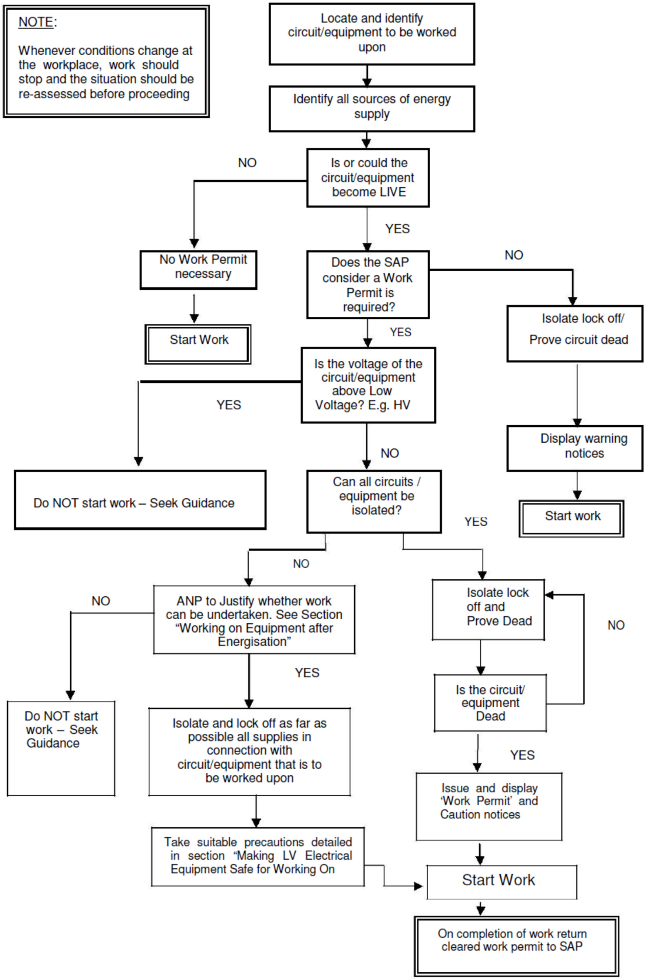

Energisation Procedure
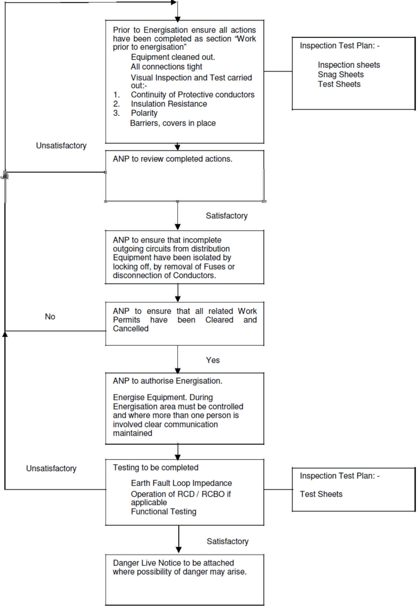

Electrical Inspection, Test & Commissioning Procedure

Purpose
The purpose of these procedures is to ensure that COMPANY NAME manage the control of electricity and ensure a safe working environment for employees, visitors, and other contractors, as well as the buildings future occupants during the operations involved in testing, energising and commissioning the various electrical installations on this project.

The control of electricity presents numerous hazards and COMPANY NAME accepts its responsibility to safe guard the wellbeing of all persons. By implementing these procedures, a safe system of work will be formulated, and as such adherence of these procedures by all COMPANY NAME personnel / sub-contractors is mandatory.

In addition to these procedures, operations will be carried out in compliance with the requirements of: -

- The Health & Safety at Work Act 1974
- The Electricity at Work Regulations 1989
- BS 7671:2008 the I.E.E Wiring Regulations 17th Edition

Scope
The procedure relates only to low voltage electrical installations. The document comprises of the test and commissioning in relation with I.E.E regulations 17th Edition Part 6 ‘Inspection and Testing’ And Guidance Note 3.

Associated Documentation

Certificates of Competence, Senior Authorised Person and Authorised Person (Document Reference 02-03-51)
Electrical Permit to Work (Document Reference 02-03-01-06)
Permit for Isolation of Supply (Document Reference 02-03-01-09)
Limitation of Access (Document Reference 02-03-01-08)
Permit to Energise (Document Reference 02-03-01-10)
Permit to work log (Document Reference 02-03-52)
Sanction to Electrical Test (Document Reference 02-03-01-07)

General Requirements

Safety
All Testing and inspections shall be carried out in accordance with the I.E.E regulations 17th Edition Part 6 ‘Inspection and Testing’ and guidance notes 3.
It is the tester’s duty to ensure his own safety and that of others in the performance of his test procedures.

When using test equipment safety is best achieved by precautions such as;

- Understanding the equipment to be used and its ratings
- Checking that all safety procedures are followed
- Checking that the instruments used conform to the appropriate British Safety Specifications. i.e. BS5458 for electrical instruments
- Ensuring that test leads including test prods and clips are in good order preferably using fused test leads where appropriate.

Attention should be paid to the safety aspects associated with any tests performed with instruments capable of generating a test voltage greater than 50V or which use the supply voltage 230V for the purpose of the test i.e. earth fault loop impedance test and RCD testing.

Results of tests and inspections will be recorded on the appropriate sheets.

In the event of any test indicating failure to comply, that test and those preceding the results of which may have been influenced by the fault indicated, shall be repeated after the fault has been rectified. Any defects shall be reported and listed.

Information for the inspection / independent commissioning engineer
All relevant information required for the inspector can be ascertained from the following:

- System schematic drawings
- Construction drawings
- Distribution board schedules
- Cable schedules
- Earthing schematic drawings
- Appropriate draft test sheets

Note: All Live power supplies are to be controlled by the COMPANY NAME permit system and shall be locked off, dead (once electrically tested), and results are recorded.

For independent 3rd party commissioning requests for power refer to Section 9.

Witnessing
Notice will be given when testing is to start and our Client together with the Electrical Designer will be invited to inspect all records as they are produced. A percentage of those tests will be repeated in the presence of a representative of the Client to confirm the figures logged. Selection of which tests this applies to will be at the discretion of our Client.

Inspections
Generally, inspection and where appropriate testing, will be carried out progressively throughout the different stages of construction and before the installation is put into service.
The inspections to be carried out will be those as detailed in the I.E.E Regulations Part 6 Chapters 61-63 with reference to Guidance Notes 3.
Where sections of the installation have been inspected, an Inspection / Record sheet will be completed (Draft Test Certification) and retained on site. Any defects noticed will be recorded on an Inspection / Record sheet, remedied and the installation further inspected, and a further Inspection / Record sheet produced.

Inspection / Record sheets produced will be available for inspection by the Client as required.

Inspections to be carried out but not limited to shall include the following:

a) Initial Verification I.E.E regulation 612.1 to 612.14

An inspection to verify that the installed electrical equipment is in compliance with British standards or the equivalent harmonised European standard.
Equipment correctly selected and erected in accordance with the regulations, equipment is not visibly damaged or defective so as to impair safety.

b) b) I.E.E regulation 611

The inspection shall include the checking of the items shown in the above extract.

Pre-Energisation Checks of Mains and Sub Mains

Generally, checks and where appropriate testing is carried out before the installation is put into service. Any exclusion will be noted.

The inspections and tests to be carried out will be as those detailed in the I.E.E Regulations Part 6 and the sequence of tests defined within the Guidance Notes 3 ‘Inspection and Testing’ of the 17th Edition of the Wiring Regulations.

Pre-Energisation Checks

Before power is applied to any low voltage sub circuit fed from distribution boards and switchgear the following tests and checks shall be carried out. Prior to testing of any circuit, the circuits shall be verified made safe by removal of fuses or locking off isolating devices.

- The final sub circuit has been inspected to make sure it is complete in every aspect and no cables are left unconnected.
- Carry out earth loop resistance test of the CPC and enter the readings in the appropriate column of the test results sheet.
- The continuity of phase, neutral and CPC of all final sub circuits will be measured at the distribution board, ring final sub circuits will be measured between the ends of each conductor before connecting as a ring circuit following the three-step method defined within Guidance Note 3.
- Carry out insulation resistance tests on cabling including phase to earth/neutral and phase to phase tests. Before testing check that all the following equipment are disconnected:
- Pilot or indictor lamps and capacitors to avoid an inaccurate test value being obtained.
- Voltage sensitive equipment such as dimmer switches, touch switches, delay timers, power controllers, electronic starters for fluorescent lamps etc. so that they are not subject to the test voltage.
- There is no electrical connection between any live conductor and earth.
Should any of the readings taken differ greatly then further investigations should be carried out to determine the cause. Where circuits contain two-way switching, the two-way switches will be operated, and another test will be carried out to include the ‘strapping’ cables which were not previously included in the test.
All tests will be carried out at the main switch or distribution board serving the area under test. They will be carried out in the following sequence.

Single Phase

Phase L1 and earth Phase L1 and neutral
Test between neutral and earth

Three Phase

Phase L1 and Phase L2 Phase L2 and Phase L3 Phase L3 and Phase L1 Phase L1 and earth Phase L2 and earth Phase L3 and earth Phase L1 and neutral Phase L2 and neutral Phase L3 and neutral
Test between neutral and earth

Note: All Live power supplies are under COMPANY NAME safe systems of work procedures (Permit System) and shall be locked off, dead (once electrically tested), and results are recorded.

Incoming Main

The incoming main supply must not be switched on until the following actions have been taken by the COMPANY NAME site designated Senior Appointed Person / Appointed Person: -

- Notices of powering up have been sent to all parties and the site is made fully aware.
- All required dead electrical inspection and testing processes have been completed and documented.
- A Sanction to Electrical Test (Document Reference 02-03-01-07) has been issued and authorised
- All isolation devices to the electrical installation have been opened and securely locked in that position.
- All covers are in place on the equipment and terminations tight.
- Provision has been made for the switch room to be locked and under control of the COMPANY NAME Authorised Person(s).

Sub Mains

Sub Main supplies to section boards must not be energised until the following actions have been taken:

a) The Sub Main cable installation inspected and electrically tested, and results documented.
b) The isolator at the remote end of the sub main cable has been locked off.
c) Any sub circuits in the equipment supplied by the sub main cables has been safely isolated.
d) All covers are in place on the equipment for the sub main supplies.
e) A warning notice has been posted on the cover of the sub main equipment.

Note: All Live power supplies are under COMPANY NAME safe systems of work procedures (Permit System) and shall be locked off, dead (once electrically tested), and results are recorded.

Sub Distribution Boards

Sub Distribution Boards must not be made live until the following actions have been taken: -

- Each sub circuit connected to an outgoing way of the sub distribution board has been inspected for completeness and electricity tested with the results recorded. Note that any partially complete sub circuits must be safely isolated.
b) All covers are in place on the sub distribution board.

Note: All Live power supplies are under COMPANY NAME safe systems of work procedures (Permit System) and shall be locked off, dead (once electrically tested), and results are recorded.

Checks After Energising of Mains and Sub Mains Supplies

Tests will be carried out with the system energised.

The tests to be carried out will be as those detailed in the I.E.E Regulations and as described in ‘The Sequence of Tests’ of the Guidance Notes 3 ‘Inspection and Testing’ of the 17th Edition of the Wiring Regulations.

The tests to be carried out will be: -

a) With supply connected re – check polarity before further testing.
b) Earth Loop Impedance, Prospective fault current.
c) Residual current devices.

Directly prior to energisation, an appropriate warning label should be attached to the distribution board, warning that the board is ‘LIVE’ and access will only be permitted with a valid safety document. Appropriate barriers shall be erected to prevent unauthorised access i.e. switch room doors, etc.

Prior to energisation of main and sub main cables, the test engineer will conduct an examination of the complete circuit and ascertain if any other contractor’s equipment is connected to the circuit. If so, then the Client will be advised. If necessary, the interfacing contractor’s equipment will be isolated, and the circuit test will be conducted. Other contractor’s equipment will NOT be initially energised by COMPANY NAME.

With the main isolator switched to the OFF position on the distribution board the supply can be switched ON. Measure the earth fault loop impedance (Zs) at the incoming side of the distribution board and record the reading in the appropriate column on the test result sheet. Measure the incoming voltage to the distribution board, record phase to phase and phase to neutral voltage. Using a phase rotation meter, check the incoming phases are of the correct rotation and that the cable connections correspond accordingly.

Note: All Live power supplies are under COMPANY NAME safe systems of work procedures (Permit System) and shall be locked off, dead (once electrically tested), and results are recorded.

Checks and Tests After Energising of Final Sub Circuits

- Measure the earth fault loop impedance at the source of the distribution board supply and record the reading in the appropriate column on the test result sheet.
- Where circuits are protected by residual current devices tests shall be carried out to prove that the unit operates at its fault level, the unit should not operate at 50% of its rated residual current.

The following shall be carried out in the sequence listed below: -

- Set the tripping current to x1 of the RCD rated tripping current and record the tripping time in milliseconds.
- Set the tripping current to x5 of the RCD rated tripping current and record the tripping time in milliseconds.

Measure the earth fault loop impedance of all luminaires and socket outlets and record the highest reading in the appropriate column on the test result sheet.

Note: All Live power supplies are under COMPANY NAME safe systems of work procedures (Permit System) and shall be locked off, dead (once electrically tested), and results are recorded.

Description of Control Systems

Prior to any equipment being energised control measures are put in place to prevent any access by unauthorised persons, these include: -

• Lockable doors in place to prevent entry
• Signage to warn persons of the danger
• Notices showing that the area is restricted ‘Permit to Work’

Note: All Live power supplies are under COMPANY NAME safe systems of work procedures (Permit System) and shall be locked off, dead (once electrically tested), and results are recorded.

Electrical switch rooms and riser rooms that contain ‘LIVE’ equipment is to be locked, with the keys located within lockable key boxes, which are kept in COMPANY NAME site office. These keys are to be signed out using the key register by one of the Authorised Persons, depending on the task to be carried out within these rooms under a valid and relevant permit.

At conclusion of the task, keys and signed off permits are to be returned to COMPANY NAME to be cancelled; these cancelled documents are kept within the permits section of HS&E file. All outgoing circuits from LV panels or distribution boards will be fitted with locks to prevent their energisation. The keys to these locks will be kept in lockable key boxes situated within COMPANY NAME site office under the direct control of the Authorised Person(s).

Outgoing circuits will only be energised by an Authorised Person on confirmation that it is safe to do so; this will be confirmed by the production of dead test results and a visual inspection of the area to be energised. All other trades requiring access to work within rooms containing ‘LIVE’ electrical equipment will need to apply for a Limitation of Access Certificate from a COMPANY NAME Authorised Person. This certificate only allows access into the room concerned and is NOT a permit to work on or near to exposed ‘LIVE’ equipment.

Test on Earthing System

Protective Earthing

Part 4 of the 17th Edition of the I.E.E Regulations states ‘In each installation main protective bonding conductors complying with chapter 41 shall connect to the main earthing terminal for that installation’, extraneous conductive parts may include the following: -

i. Incoming main water service pipes
ii. Incoming fire mains
iii. Other service pipes and ducting
iv. Air conditioning systems
v. Exposed metallic structural parts of the building
vi. The lightning protective system
vii. Incoming main gas service pipes.

Supplementary bonding conductors connecting exposed conductive parts are generally but not limited to the following: -

i. Trunking / Tray
ii. Ducting
iii. Extraneous metal work
iv. LV switchgear and motor control centres (MCC’s)

Due to the multitude of various types of exposed extraneous metallic parts within the site, the items to be bonded will be identified on an area by area basis.

Where practicable, all the above services will be connected to the nearest main earth bar, (i.e. the main earth bar which is connected directly to the earth matrix). The size of the protective bonding conductors is shown on the main earthing schematic drawings

3rd Party Commissioning Permit to Energise/ Request for Power

Request for power by 3rd party.

Note: All Live power supplies are under COMPANY NAME safe systems of work procedures (Permit System) and shall be locked off, dead (once electrically tested), and results are recorded.

If the Main Contractor or 3rd party requires a circuit to be made live for beneficial use or commissioning of their systems, COMPANY NAME will only make the circuit available once:

- A completed, signed Permit to Energise (Document Reference 02-03-01-10) has been received from the requestor
- The electrical installation for the area defined upon the permit is fully complete and fully tested
- The requestor is fully aware of the terms defined within Part 3 Conditions of the Permit;
- COMPANY NAME Senior Authorised Person / Authorised Person considers the request acceptable and safe.
- The requestor is fully aware that where COMPANY NAME are required to carry out electrical works within the defined area on the permit, the circuit shall be isolated and verified dead, and locked off whilst COMPANY NAME carry out their works.

The Requestor takes full responsibility for implementing a safe system of work for all electrical installations and equipment emanating from the isolation point made live by COMPANY NAME because of this application.

Electrical Visual Standards

Good, well managed electrical work is core to our business, and a key part of this is safe operation. This section of the procedures shows the mandatory, minimum safe standards we expect on all sites carrying out electrical works with respect to the Electricity at Work regulations 1989. They apply to all the site team - managers, supervisors, electricians and others - whether they be employees or sub-contractors.

Site teams must ensure the following standards are met and checked regularly.

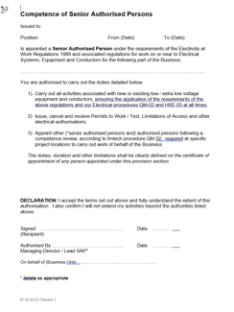

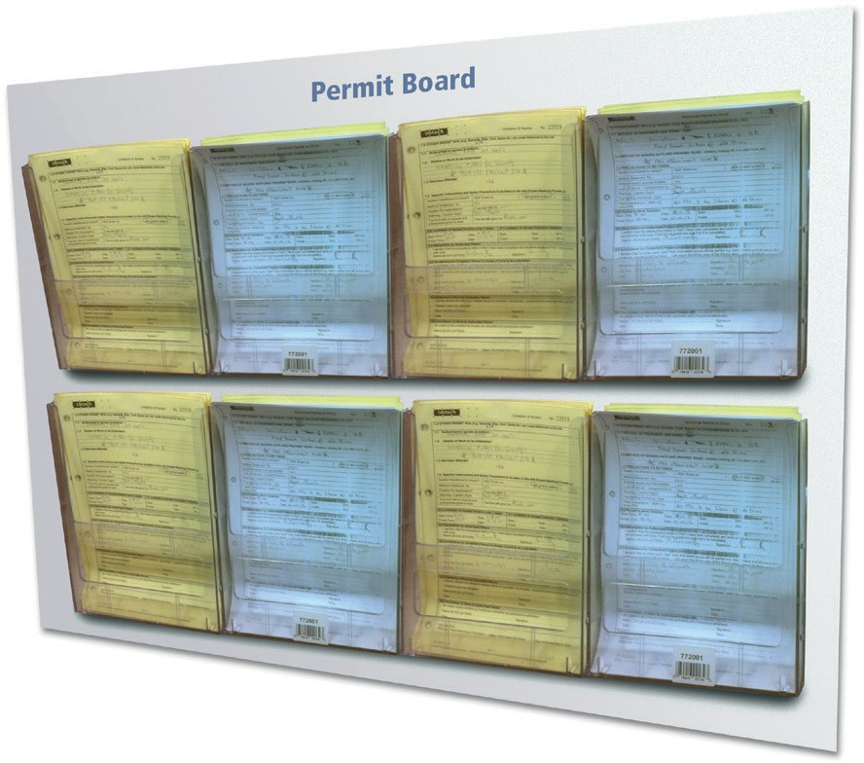
A safe system of work must be in place at site set up. Only Authorised Persons shall issue Electrical Permits to Work and Limitation of Access to Electrical areas. Authorised persons must be certified by the Senior Authorised Person and be listed on the site HSE notice board.

All open permits to be clearly visible on a notice board.

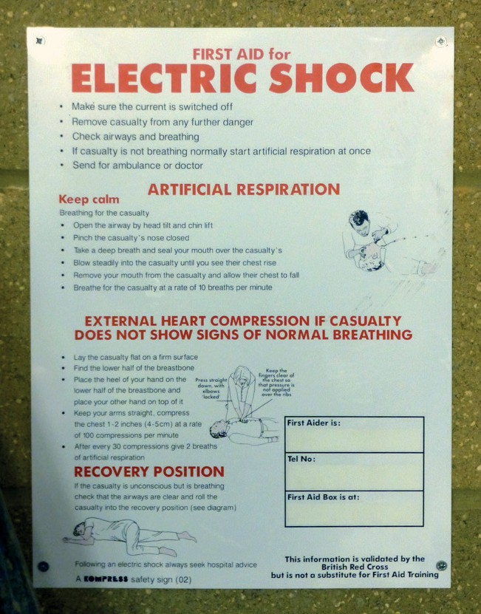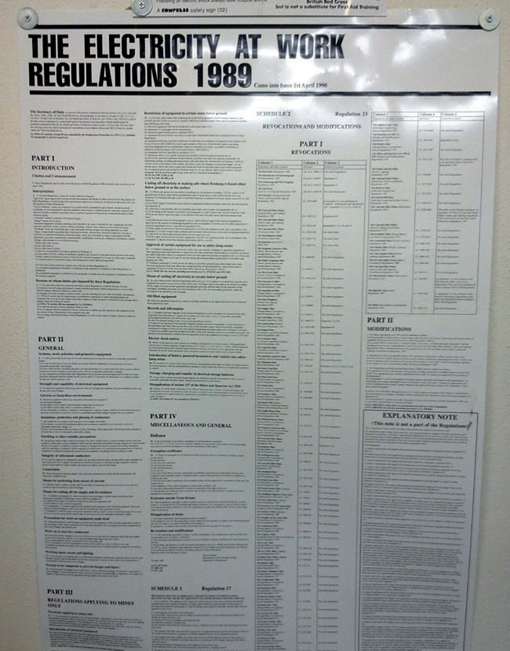

Switch rooms to have correct signage.

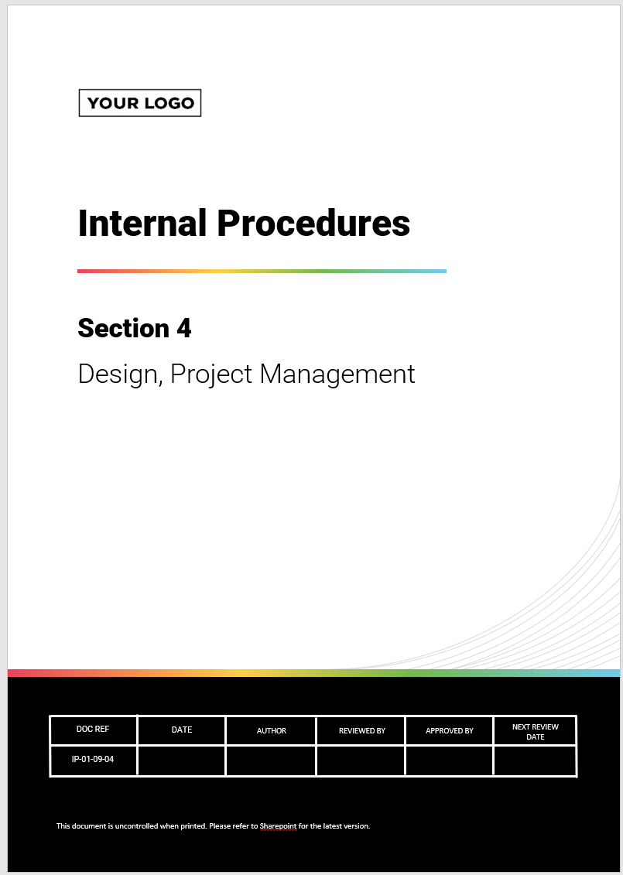

COMPANY NAME electrical safe working procedures must be available on site and issued to the relevant site sub-contractors and the client.

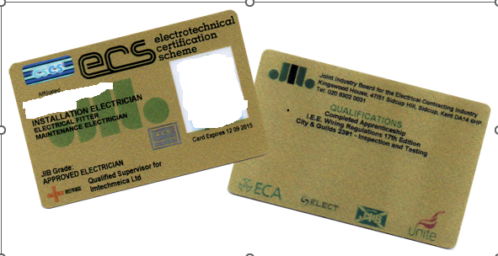

Electricians shall have a valid CSCS affiliated card (e.g. ECS) listing their qualifications. Electrical testing shall only be carried out by qualified personnel who have City & Guilds 2391 or an equivalent qualification. Agency testers shall be approved by the Senior Authorised Person.


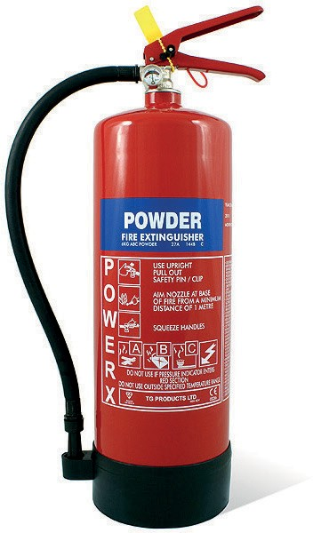

Only portable fire extinguishers suitable for electrical fires (Powder or CO2) shall be available in the vicinity of Live Apparatus and Conductors.

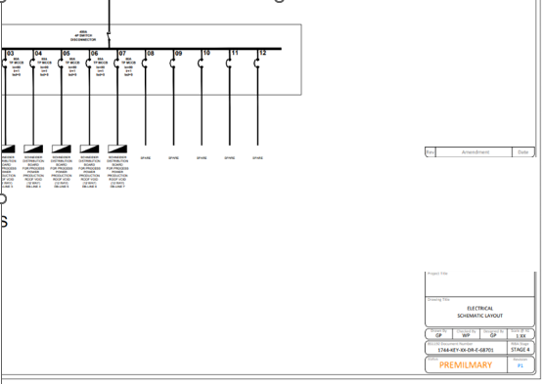

An up to date, laminated schematic diagram shall be mounted on the wall where permits are issued and in the switch room(s) to be checked against and marked up as sections become live.

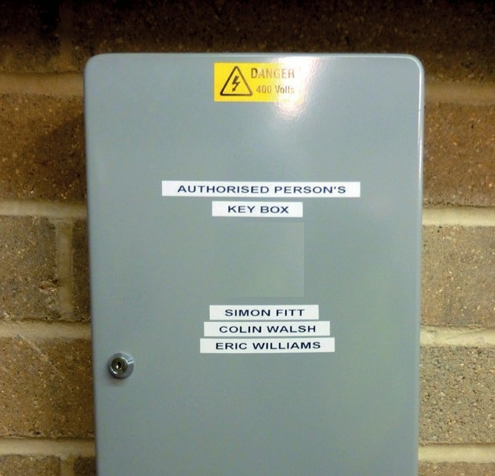
All drawings used for installation, including marked up schematics, must be the latest construction issue.

Keys shall be kept in a key cabinet complete with key register. The appointed persons shall be listed on the cover along with their telephone number.

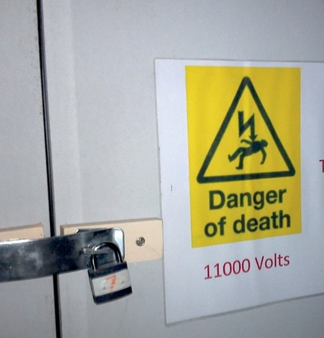

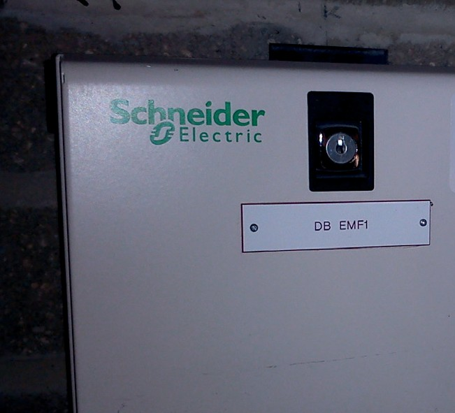
The Authorised Person shall ensure that doors are fitted to all MCC rooms, switch rooms, electrical risers, distribution boards or service cupboards containing main switchgear prior to energisation.

DB’s will be clearly labelled and will have lockable doors, whether specified or not, where possible (i.e. DB’s that cannot be fitted with a lock must be
in a lockable cupboard or switch room before being energised).

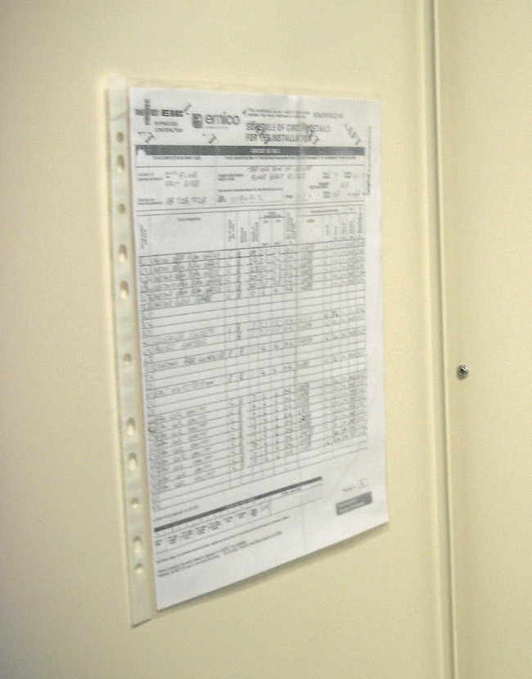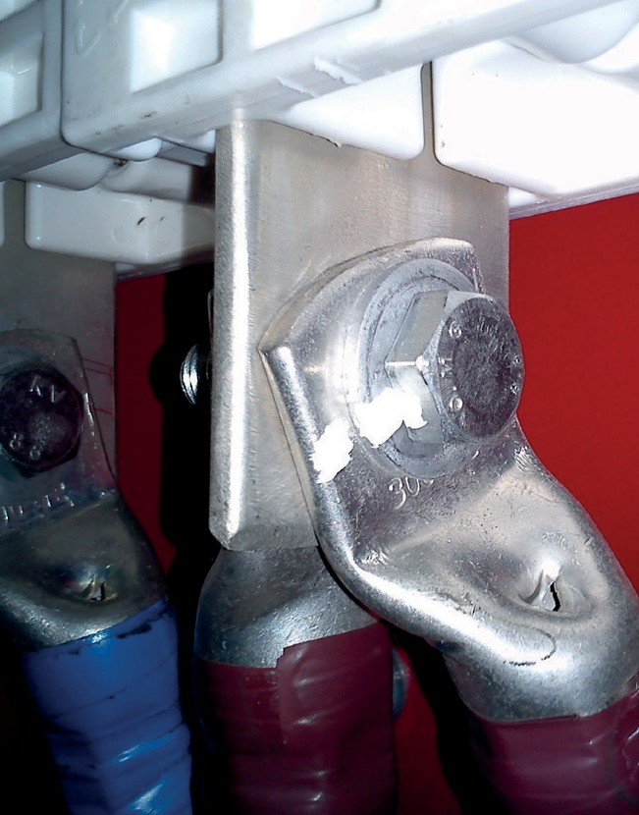

Distribution boards must be fitted with circuit charts. All terminations are to be tightened to the manufacturers specification.

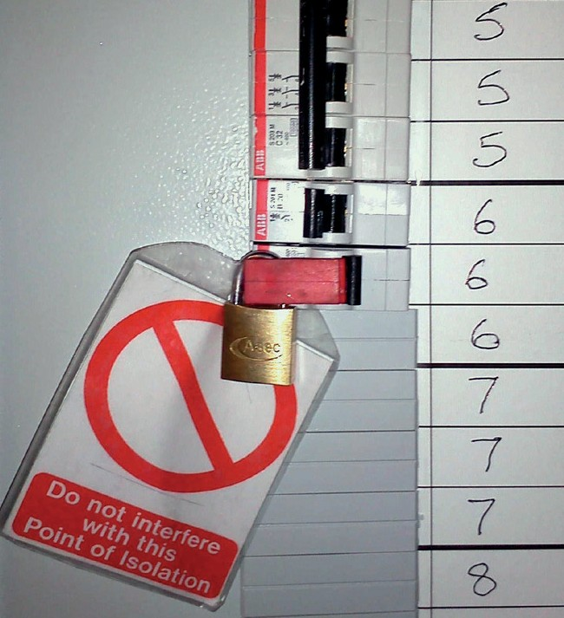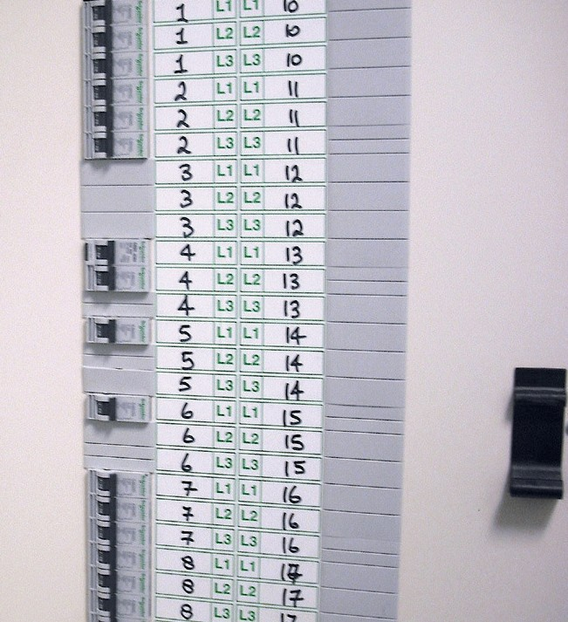

Individual isolation must be added to all incomplete circuits. MCB’s to be clearly identified. Distribution board spines should be clearly marked with circuit designation.

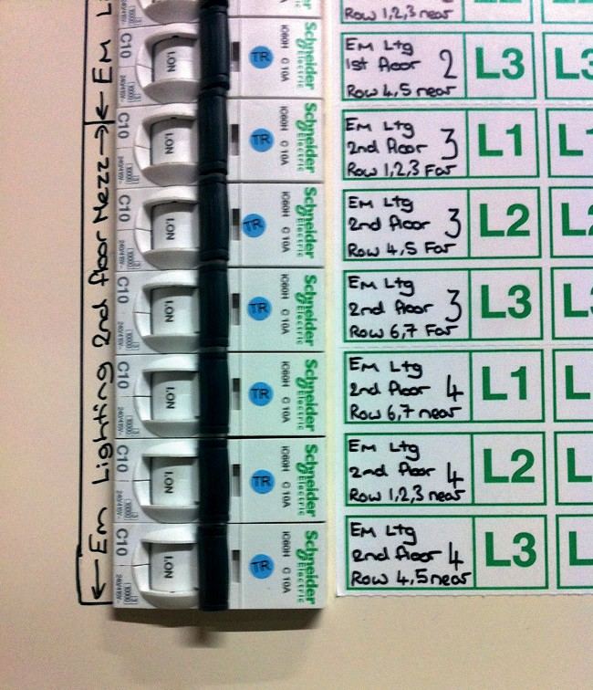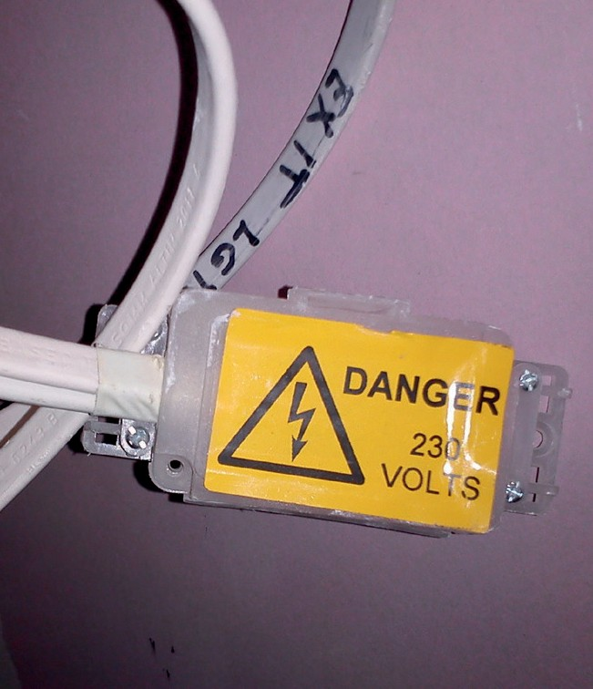

Add blue dots with testers initials once circuit has been fully tested, this clearly identifies test status. Adjacent equipment and circuits which are not complete and could be energised shall be correctly isolated using a British Standard enclosure.

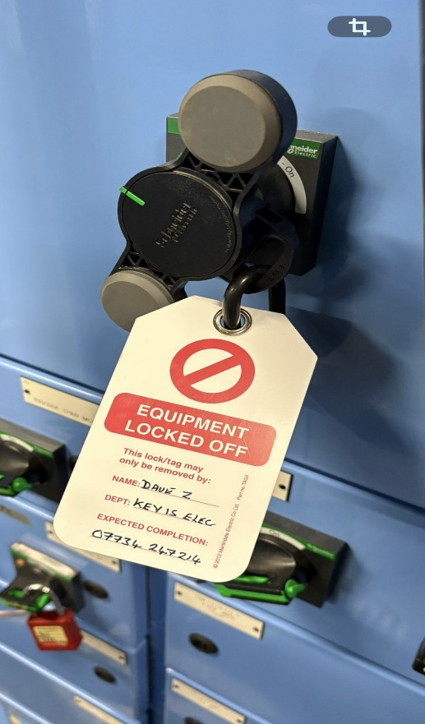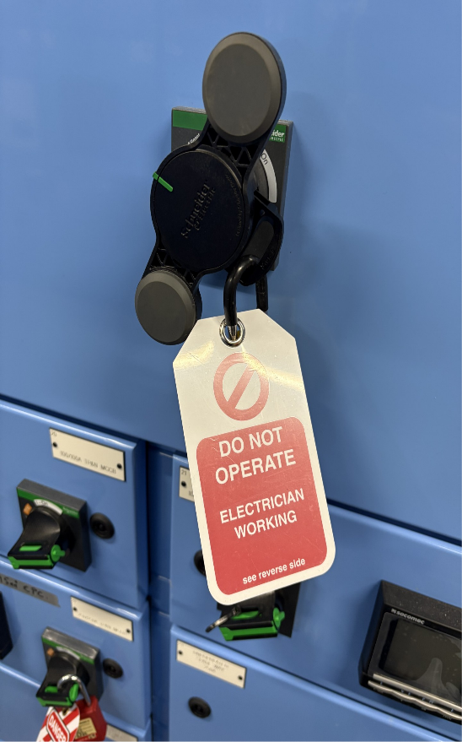

Main panel outgoing ways that have to be padlocked in the OFF position shall have padlocks keyed differently and be complete with caution notice.

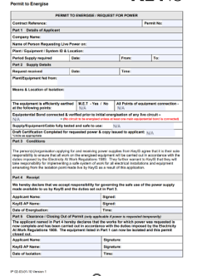

Switch gear, MCC panels, distribution boards and circuits shall only be energised on completion of a Permit for Inspection and Live Testing. Dead test results and an Energisation Checklist to be attached to the permit.
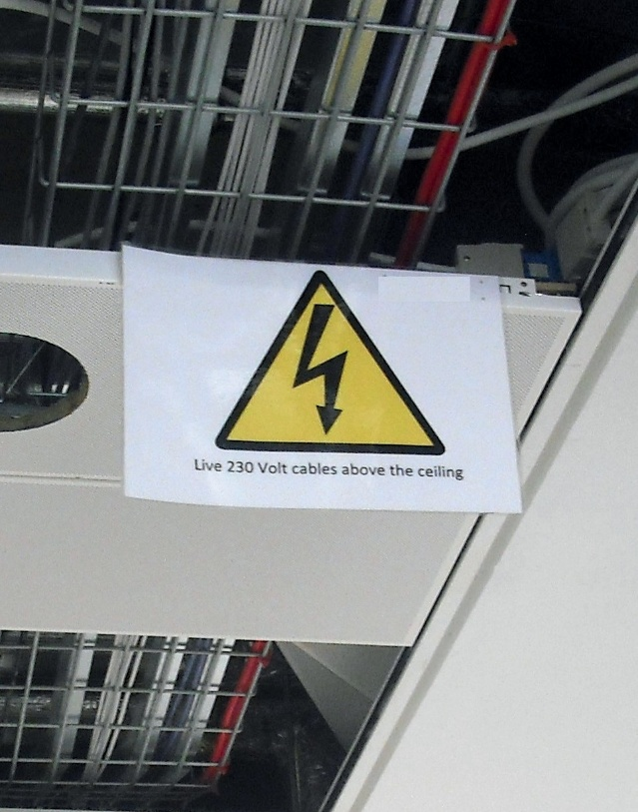

All cables and busbar distribution routes feeding out from the main switch room to sectional DB’s / Risers must be protected from access and damage.

All mains cables in areas that remain accessible shall be marked with labels clearly highlighting that the service is live. This is particularly relevant to back of house corridors, car parks and ceiling areas that are not yet completed.

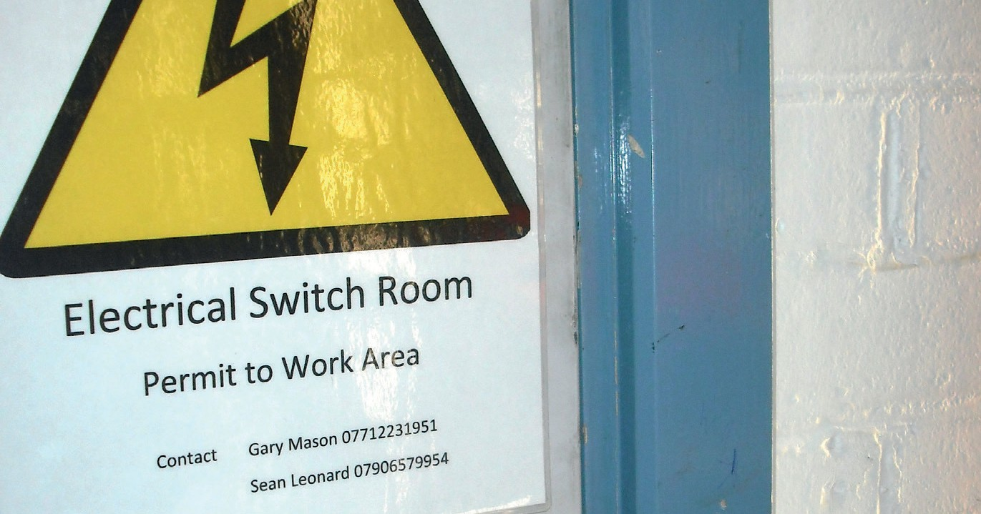
All doors fitted to MCC rooms, switch rooms, electrical risers, distribution boards or service cupboards containing main switchgear shall have appropriate warning signs (temporary or permanent). Laminated signage on MCC, switch rooms and risers shall include:

- Danger voltage Entry by permit only
- Authorised person name and contact details

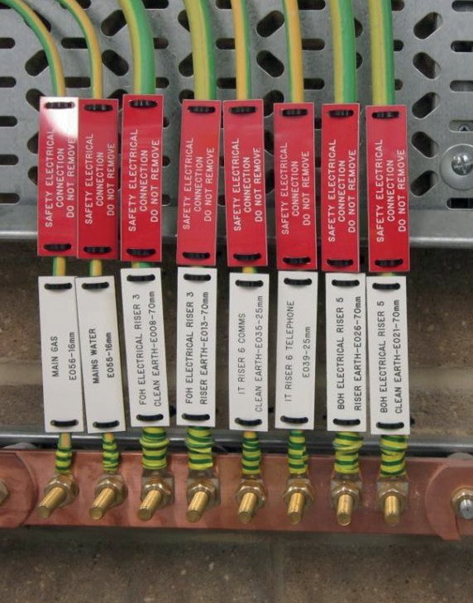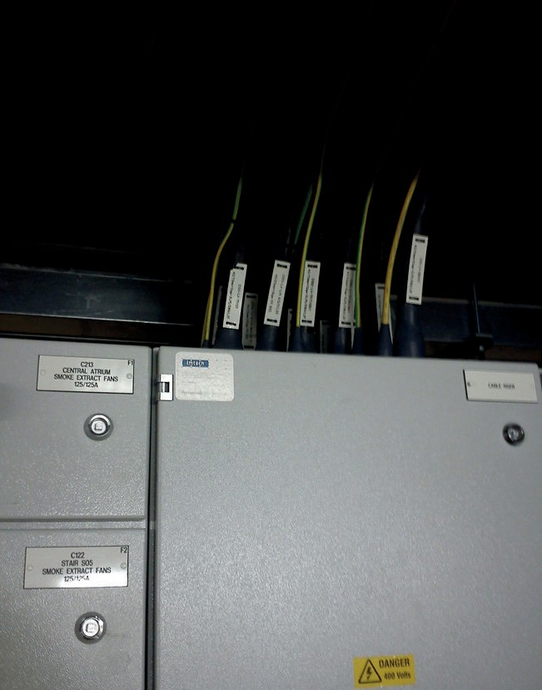

All required earthing must be in place. All outgoing cables must be labelled.

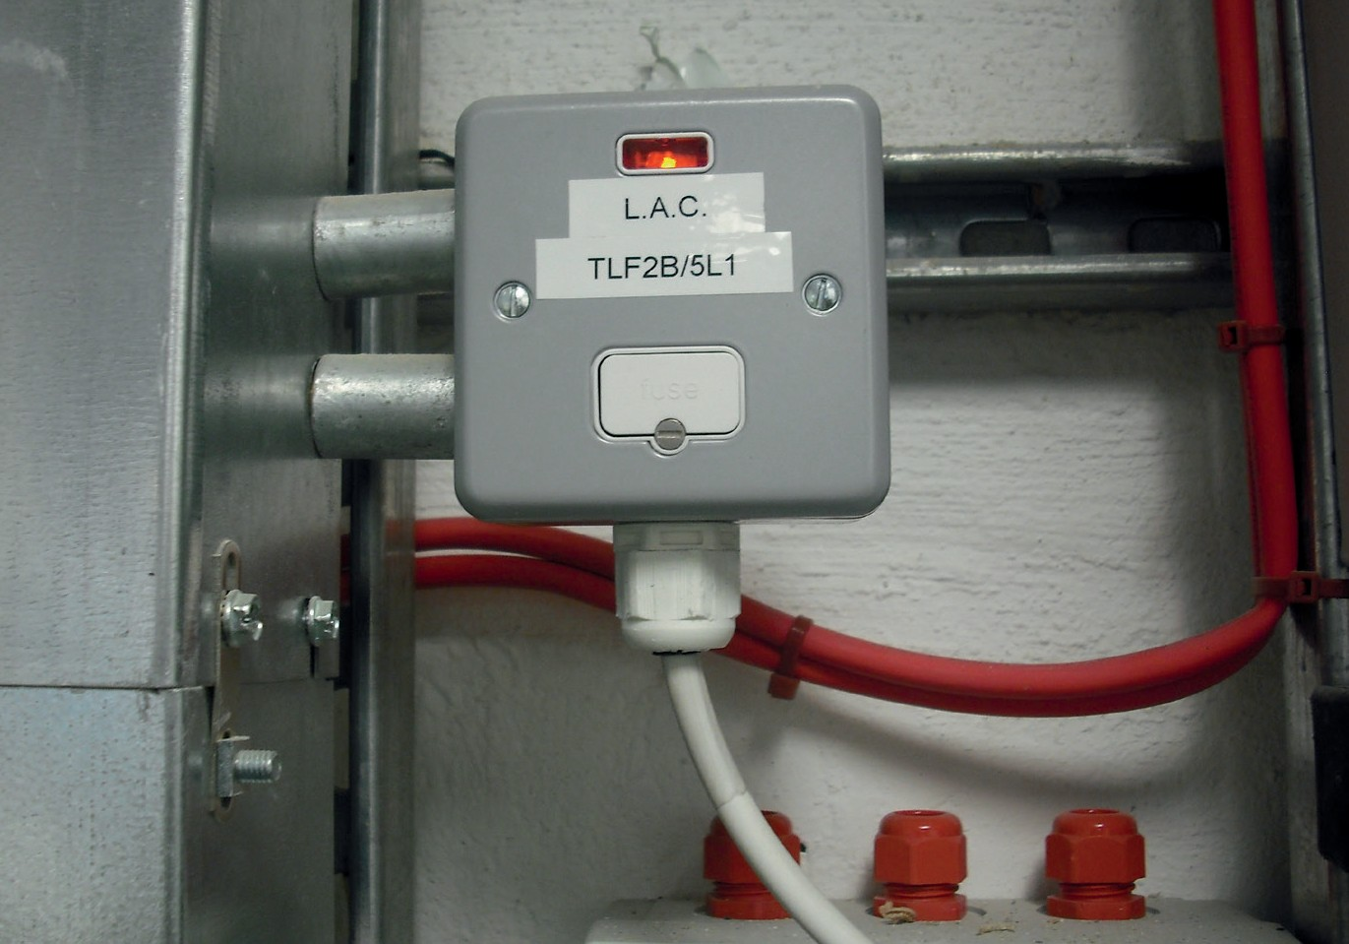
Equipment is to be clearly labelled prior to energisation.

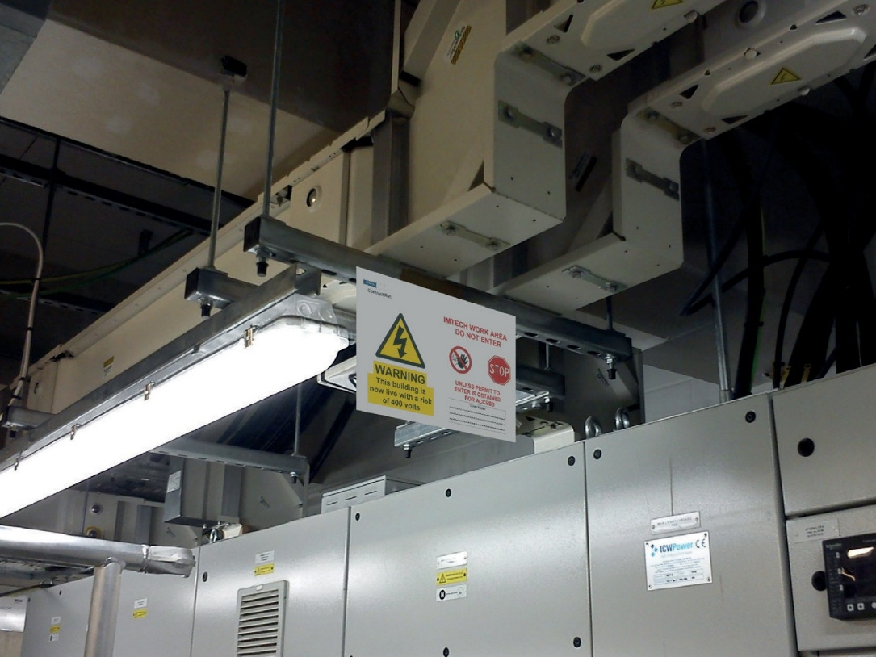

All busbars from the panel, including bus coupling connection between panels, must be complete or isolated. Signage shall be laminated.

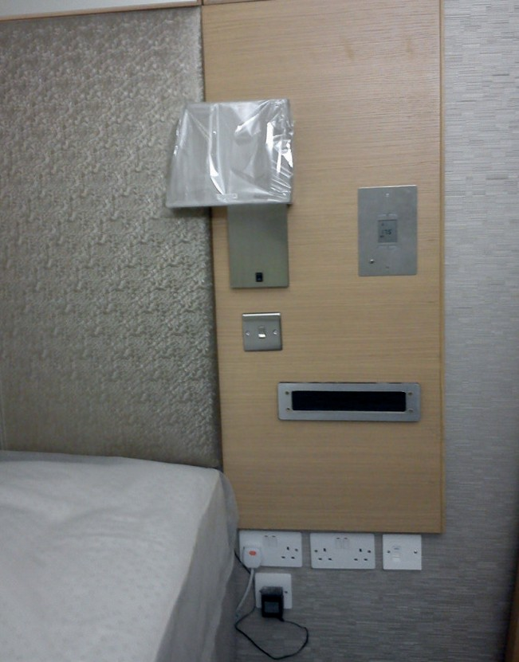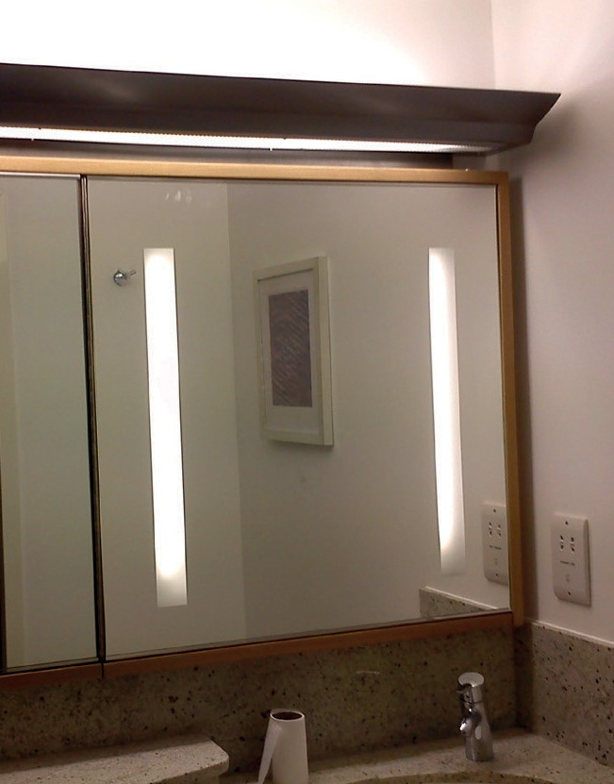

Before energisation of any system, work by all trades (e.g. electricians, builders work, fireproofing and final decoration) shall be complete in the area to be energised. Where this is not possible a risk assessment shall be completed.

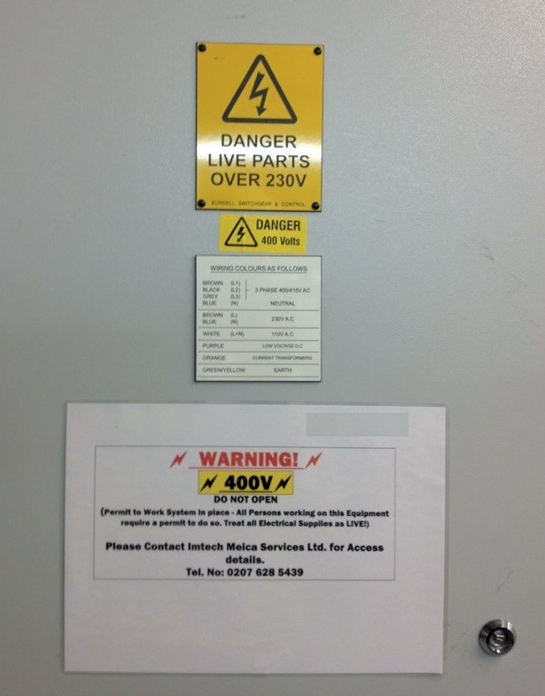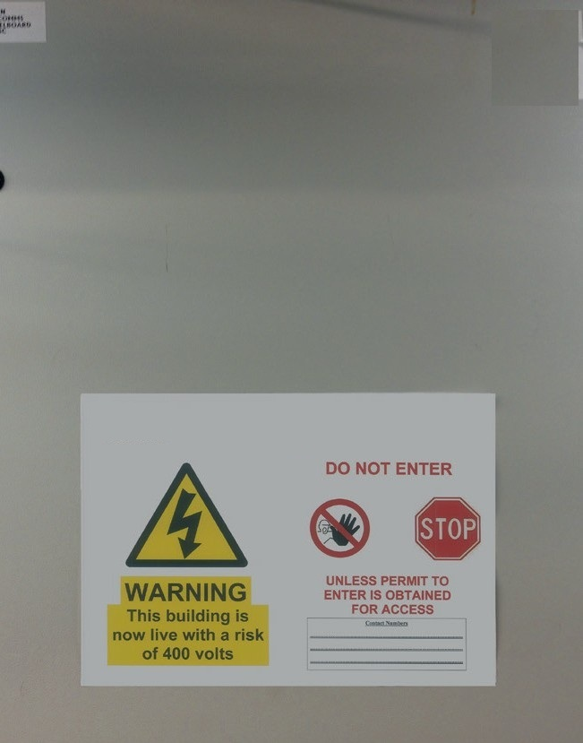

All energised electrical distribution equipment must be clearly labelled and have warning signs and display contact details of the Authorised Person.

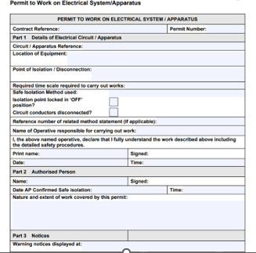

An Electrical Permit to Work shall be issued when carrying out isolation procedures.



Where the means of isolation incorporates a locking off facility this must be used, attaching an approved type of safety padlock (lock to BS EN 12320 with individual key). Caution Notices should be securely fixed to all points of isolation.

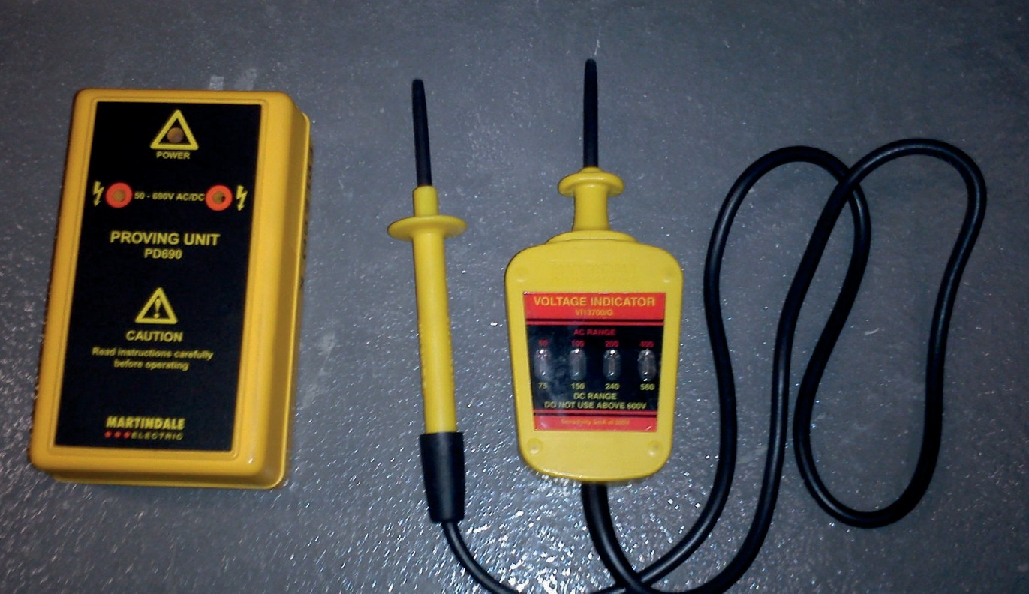

The isolated circuit shall be proved dead by means of a voltage indicator, the indicator itself being tested on a known source immediately before and after verification.

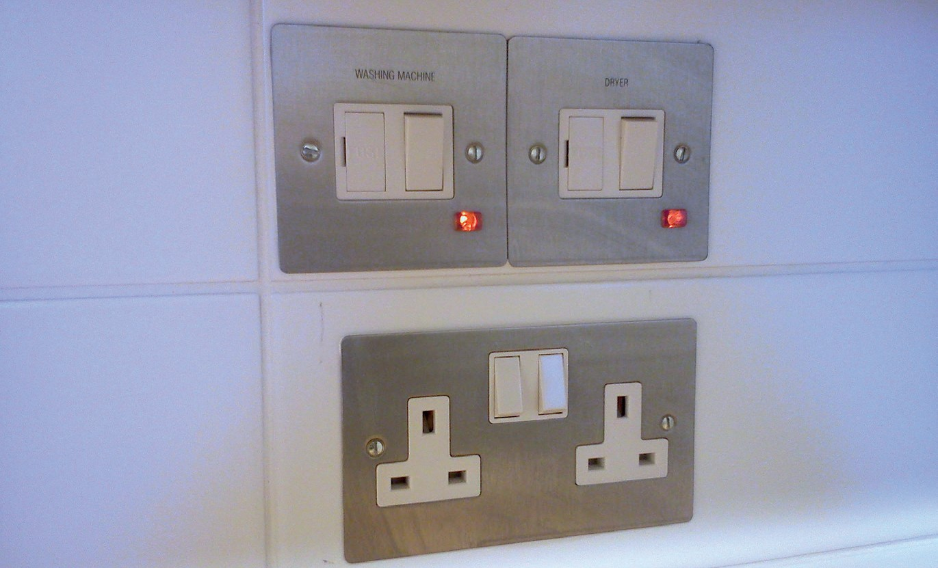

Circuits supplying socket outlets shall only be left energised where covered by an issued Request for Power Permit.

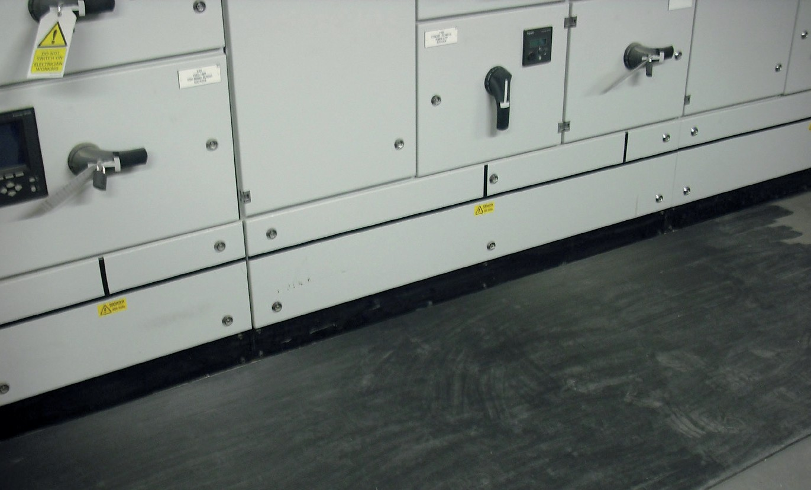

The risk assessment for live test procedures shall review the need for insulated tools, safety glasses, visors, rubber gloves or rubber mats.
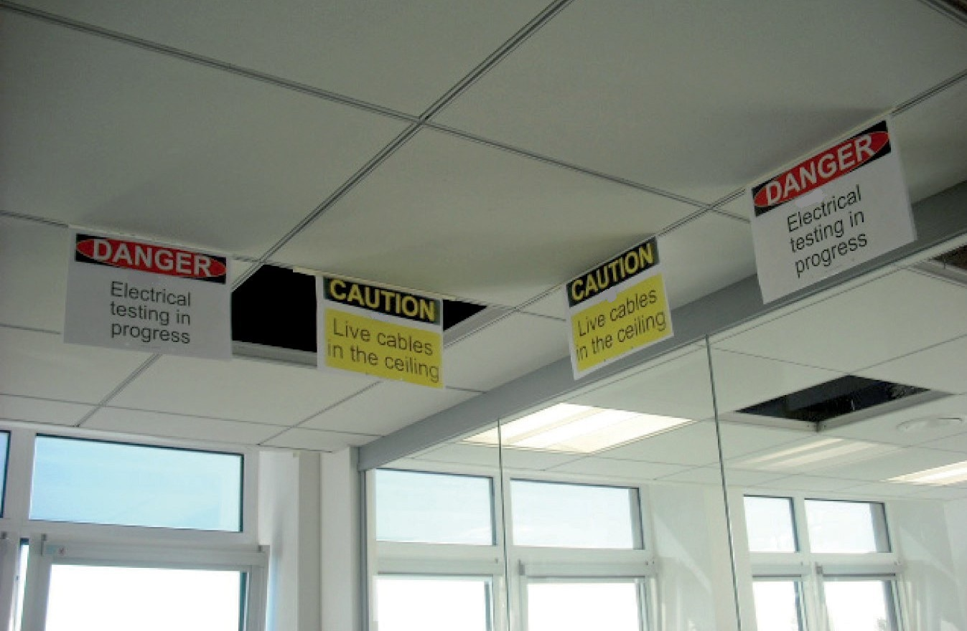

Signage must be in place and include the COMPANY NAME logo.

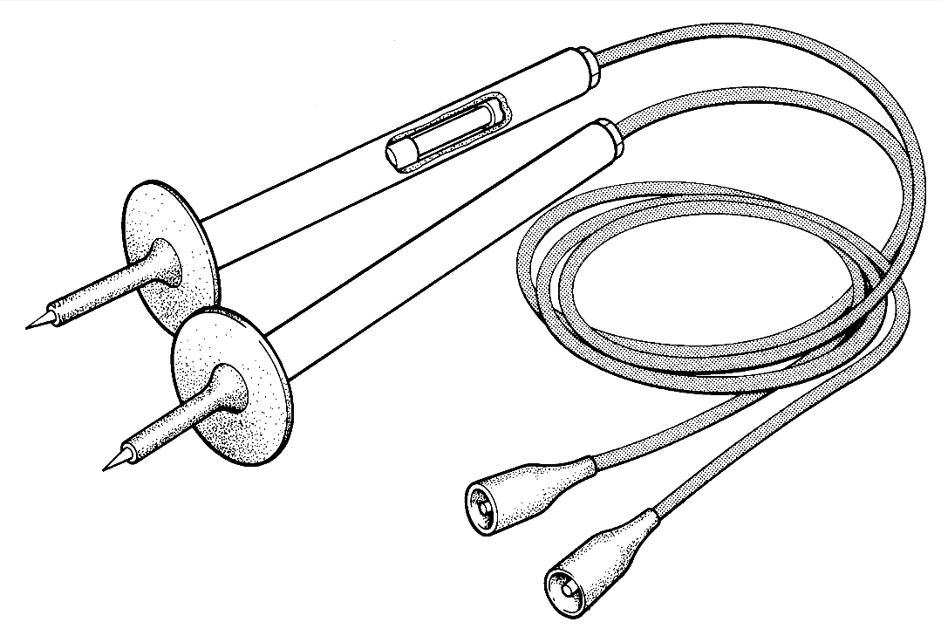
H.B.C. fuses and/or
current limitation
Barrier to prevent
access to live terminals
Robust, flexible well
insulated leads
Minimum of
exposed metal
Shrouded or firmly attached connectors

Test leads shall be GS38 compliant.

Emergency Call-out Operating Rules

- The call out rota will run for 1 x week at a time starting from 08:30 on the Monday to 08:30 the following Monday.

- The same overtime rates still apply, in addition the engineer on call will receive an additional payment per week callout fee. The callout fee must be put on the engineer’s timesheet in the expenses section when they are submitted each week.

- In the first week of each December the call out sheet ref 09-07-01 located in file 09-07 on Shaepoint must be set for the following year. A copy of the sheet must be stored in this folder & a PDF copy saved in the engineers shared file, so it is accessible for them to check.

- When the call out rota has been set, apart from sickness, it is the engineer’s responsibility to arrange with another engineer if they need to change their dates. Any changes must be noted to their manager immediately.

- When the call out rota sheet has been completed or if it is amended for any reason it must be sent to the call out centre for them to update their records so that the correct people can be contacted.

- When on call the engineer must be available at all times & have their phone with them always so they can be contacted at a moment’s notice, they must not be under the influence of alcohol or any other ability affecting substance at any time when on call. This is an emergency service for our customers & we must be there to react when they need us.

- When a customer logs a callout with the 24-hour contact centre the callout centre will first email the details to the engineer on call & then call them to confirm the details have been received. If the contact centre cannot reach the engineer after 3 attempts they will then contact the duty manager who is on call.

- Once a call has been received the engineer is to contact the customer by phone to initially see if the issue can be resolved over the phone, if it cannot the engineer is to give the customer an ETA & attend site.

- If the works are outside of the engineer’s scope, then the engineer is to attend site & make safe the situation i.e isolate the water main if it is a water leak & help to clear up the mess. In this instance the engineer is to contact the line manager on duty also to see if any alternative arrangements can be made.

- The following working day the details of any callouts, including any remedial works required must be passed onto the office so they can be actioned / invoiced accordingly.

